# Test Data and Test Document

In our project, we start to run the web application by the “index.jsp”.

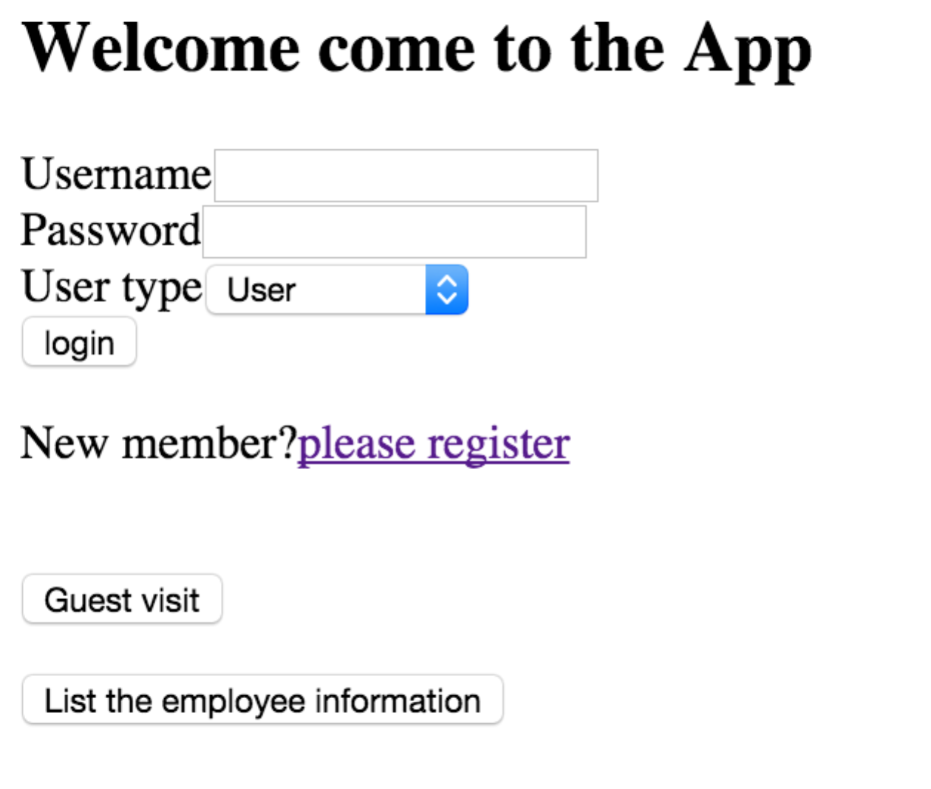

Figure 1. Index page.

## Functions of our projects:

General Processes:

### Function 1:

1. **Requirement**: Demonstrate the process of a guest registers for the first time and purchasing a ticket.
2. **Test Case**:

Click on please register the guest will enter the register page, and you are asked to provide information.

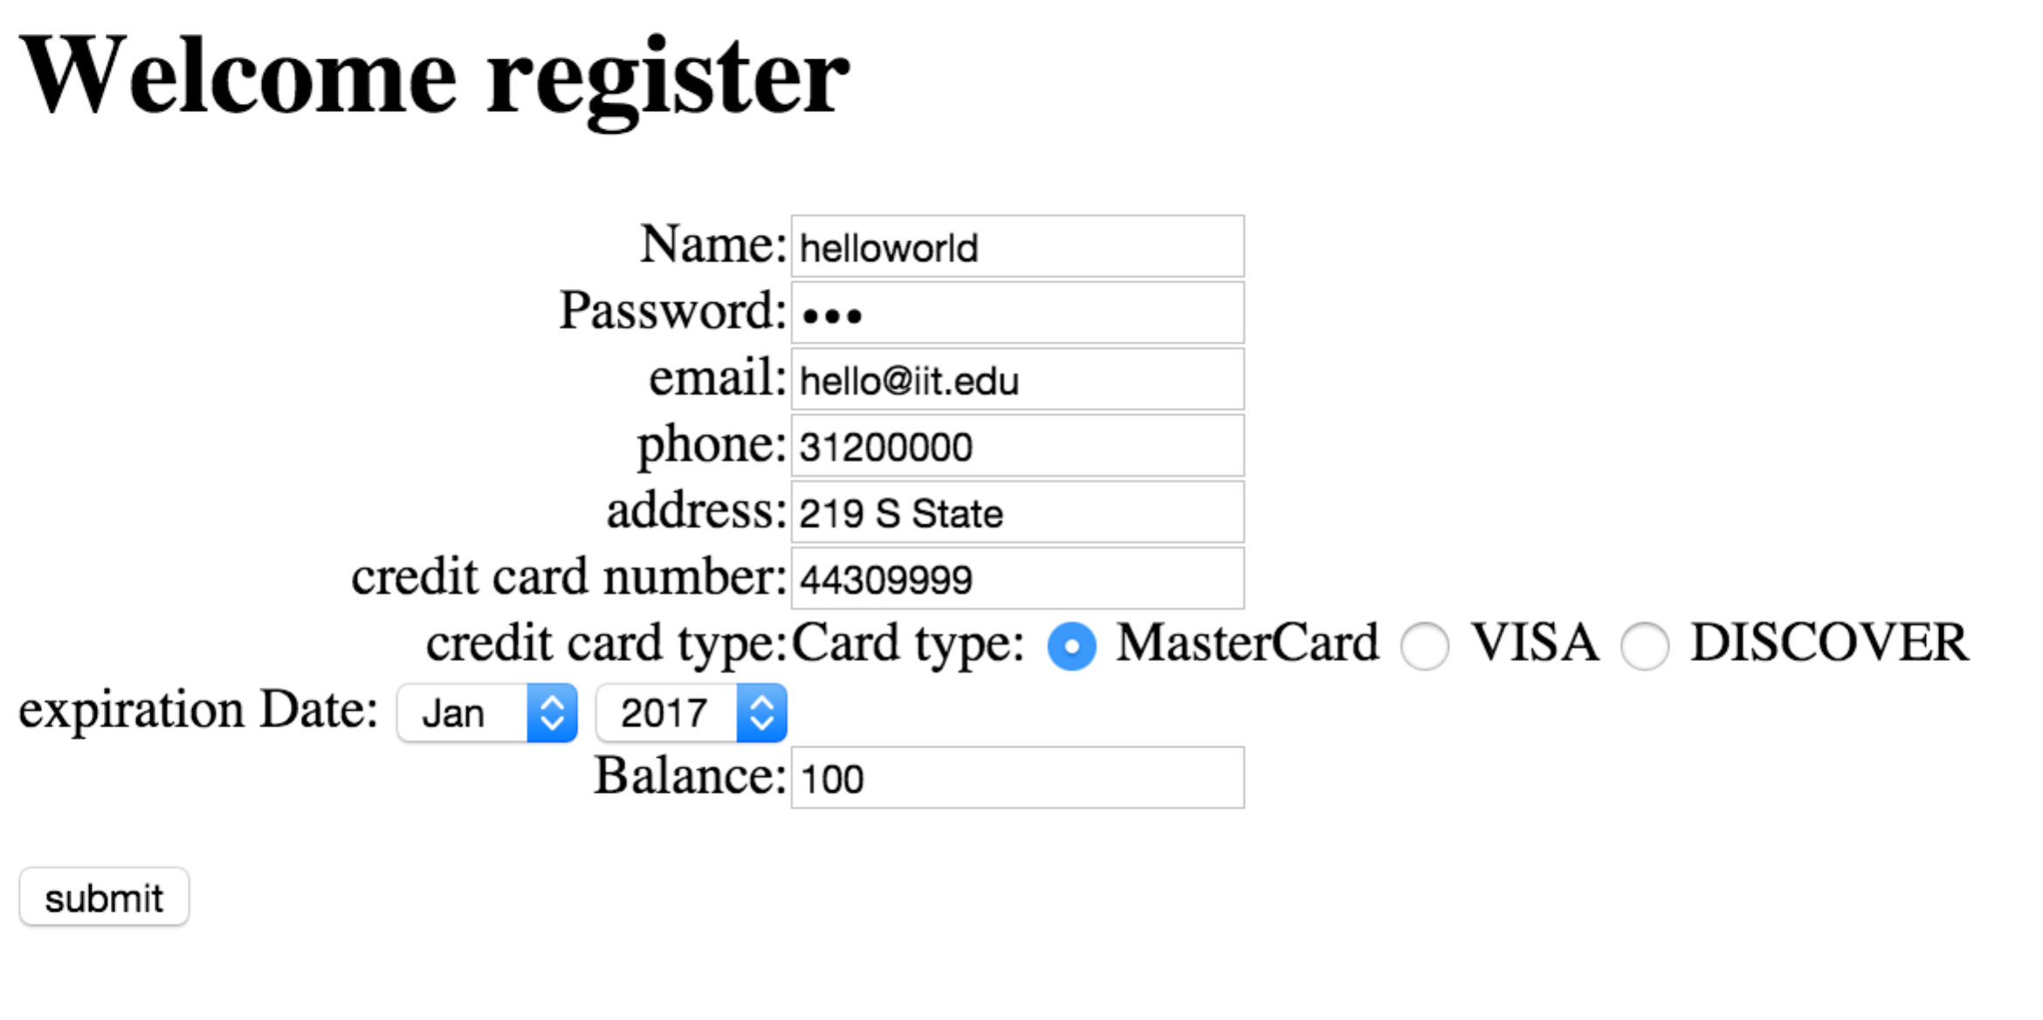

Figure 2. register page.

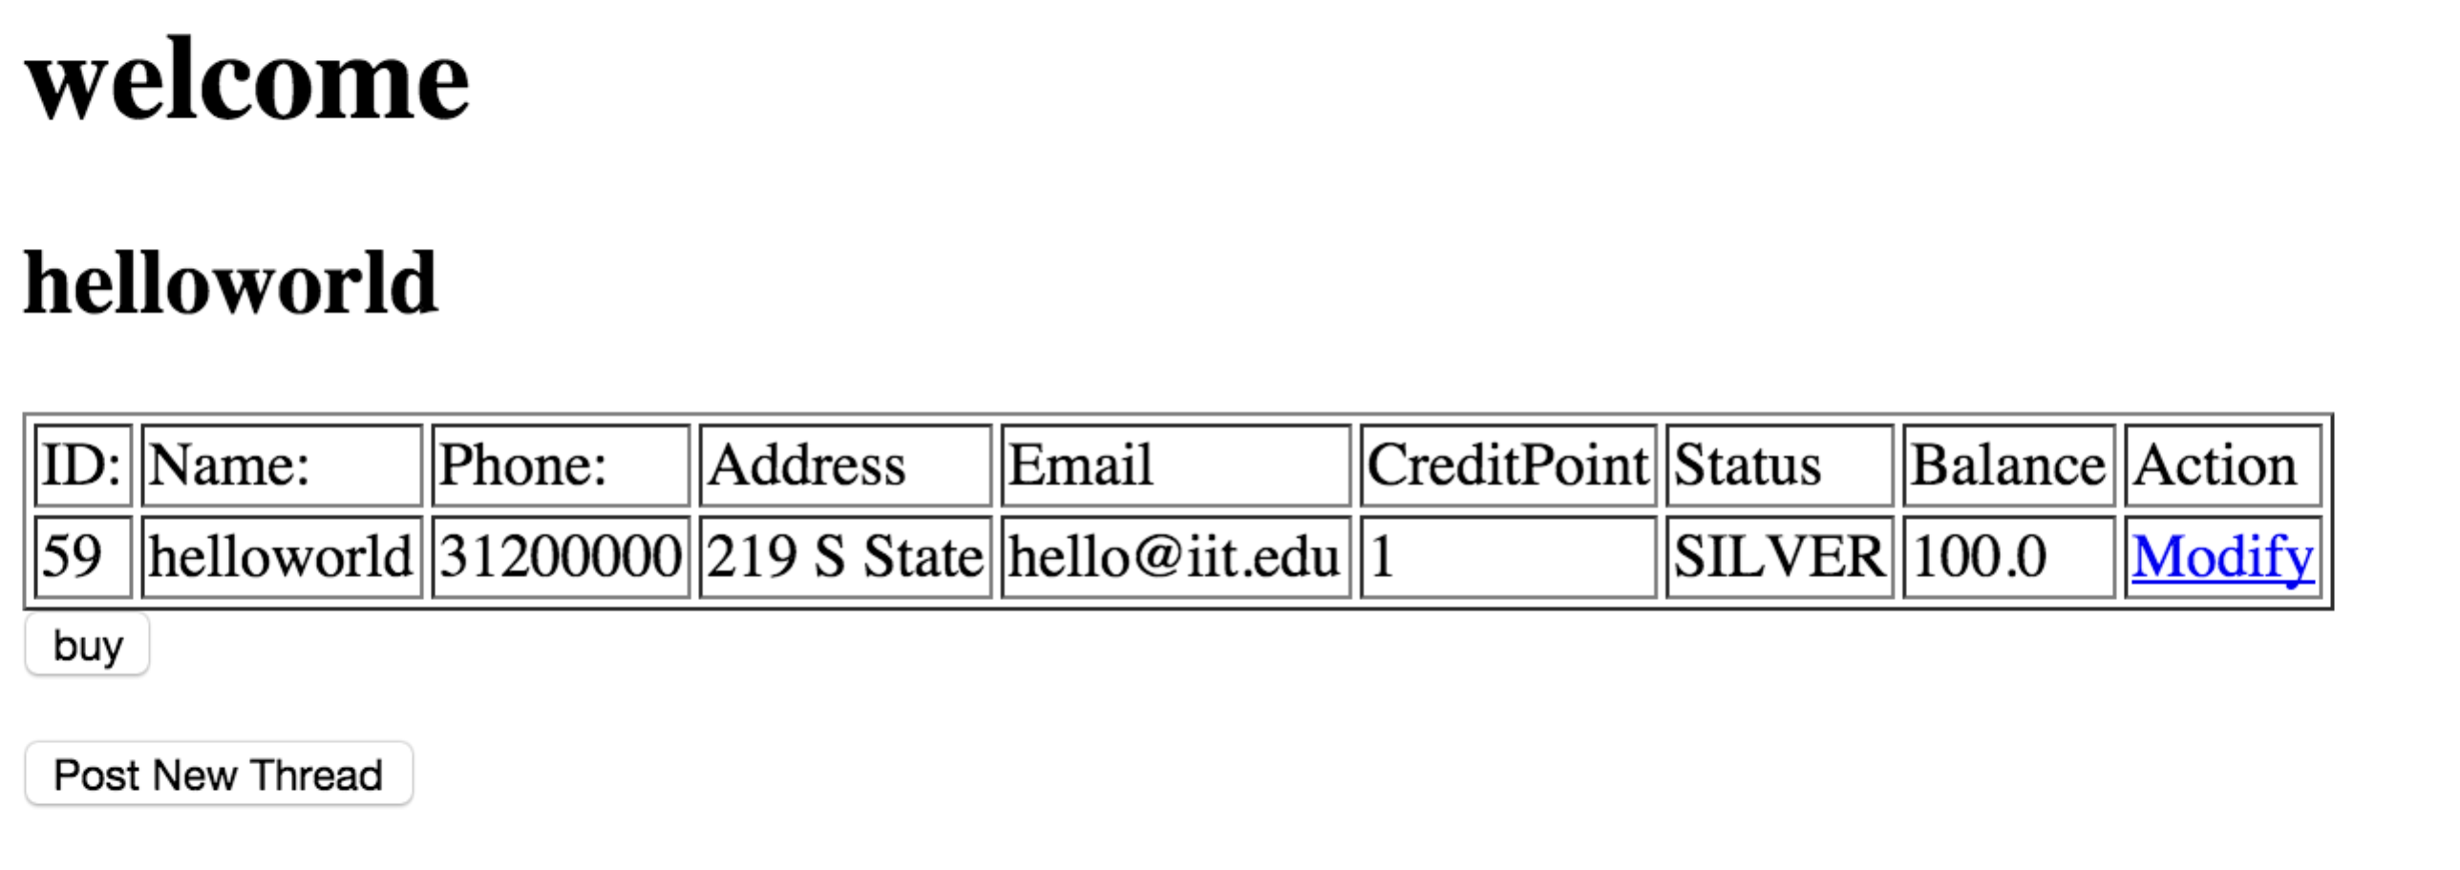

Figure 3. User accound page.

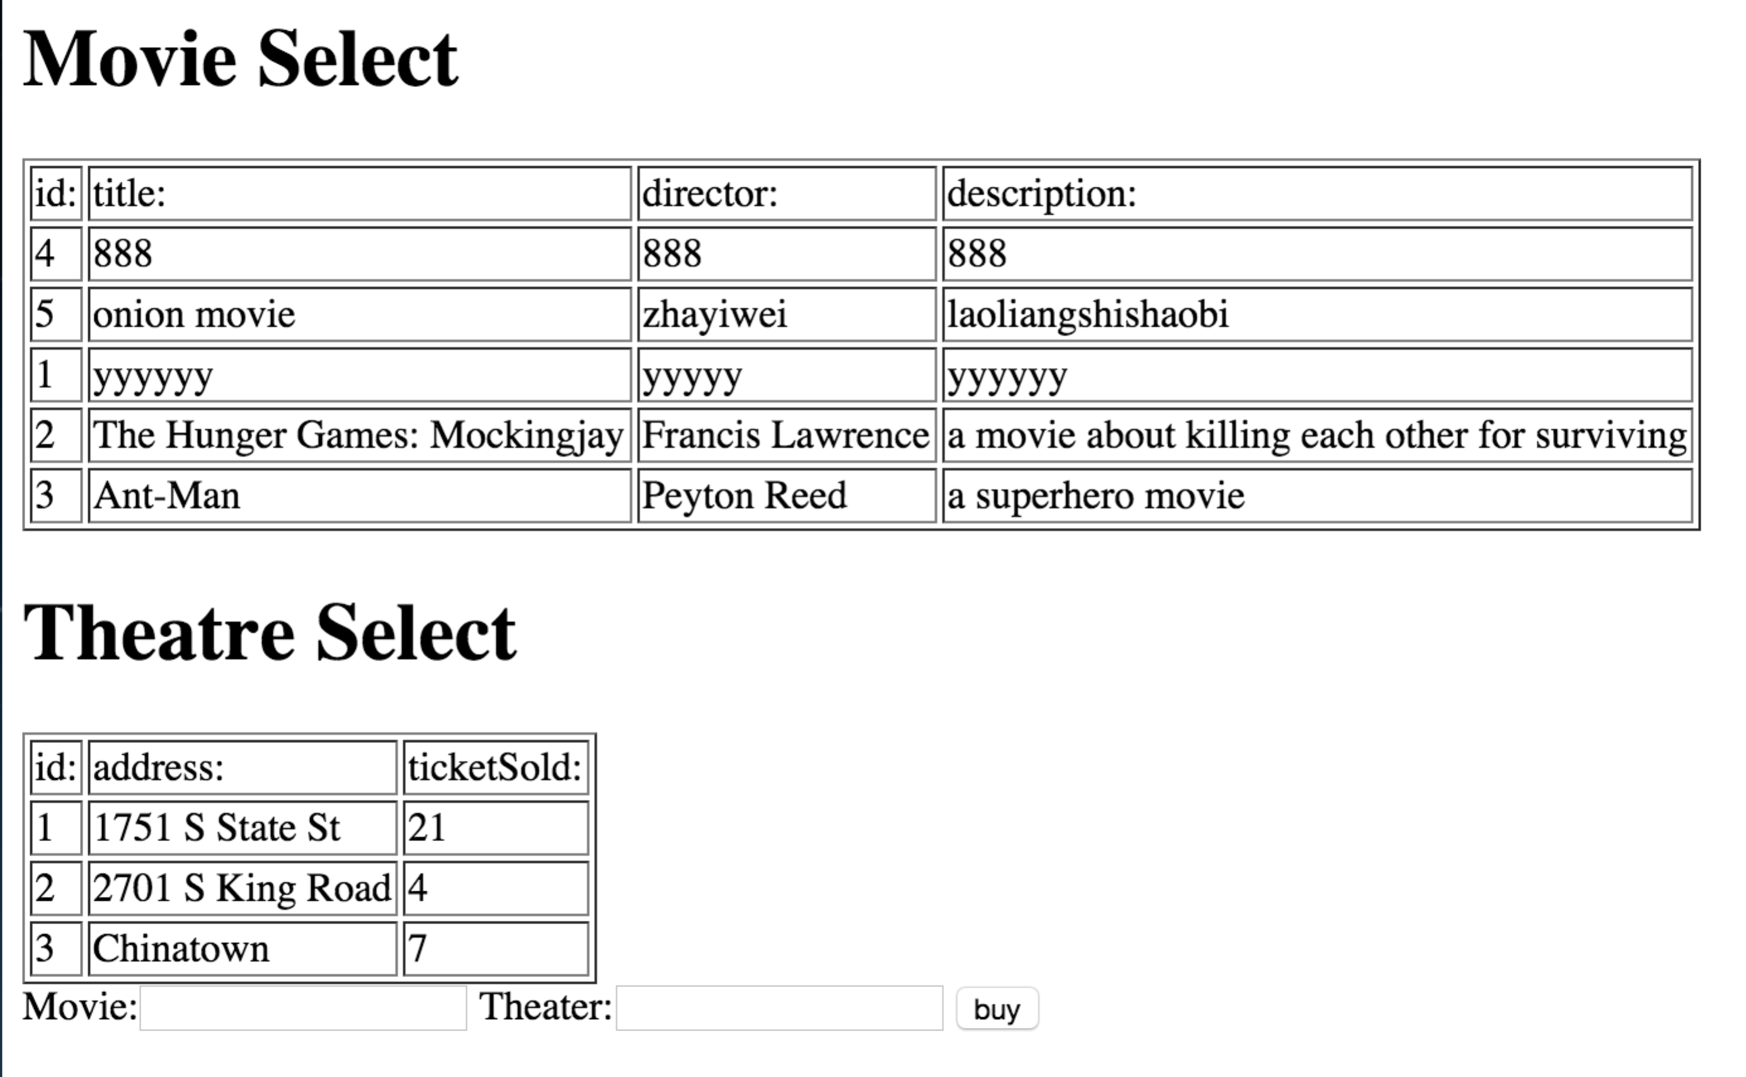

Figure 3. Buy ticket page.

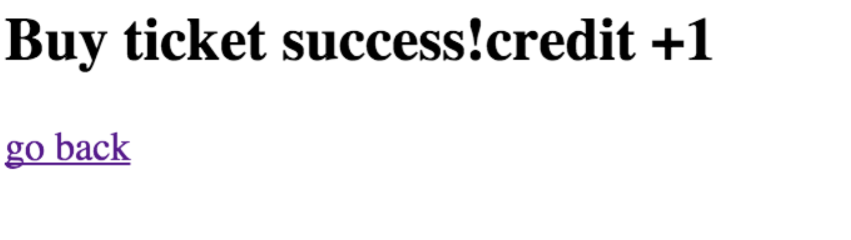

Figure 4. Buy ticket success page.

1. Expected outcome:

User information will be insert into database. When he click on “buy” button, he will enter the buy ticket page where all the movies and theatres information is listed. He should put the id of both movie and theatre in the text box and click buy, then he will see the buy ticket successful page

1. Actual outcome:

There is a record called “helloworld” in the database

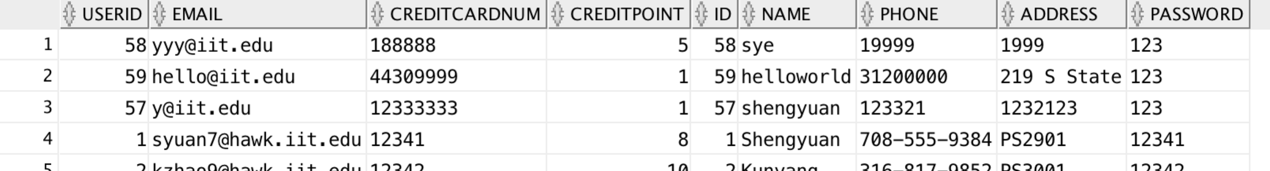

buy ticket outcome is shown above.

Figure 5 Database.

### Function 2

1. Requirement: Show the change in reward points of the above registered guest.
2. Test Case: A member can earn credit points/reward points by buying ticket (1 point/each), post threads (1 points/each) and post comments (1point/each)

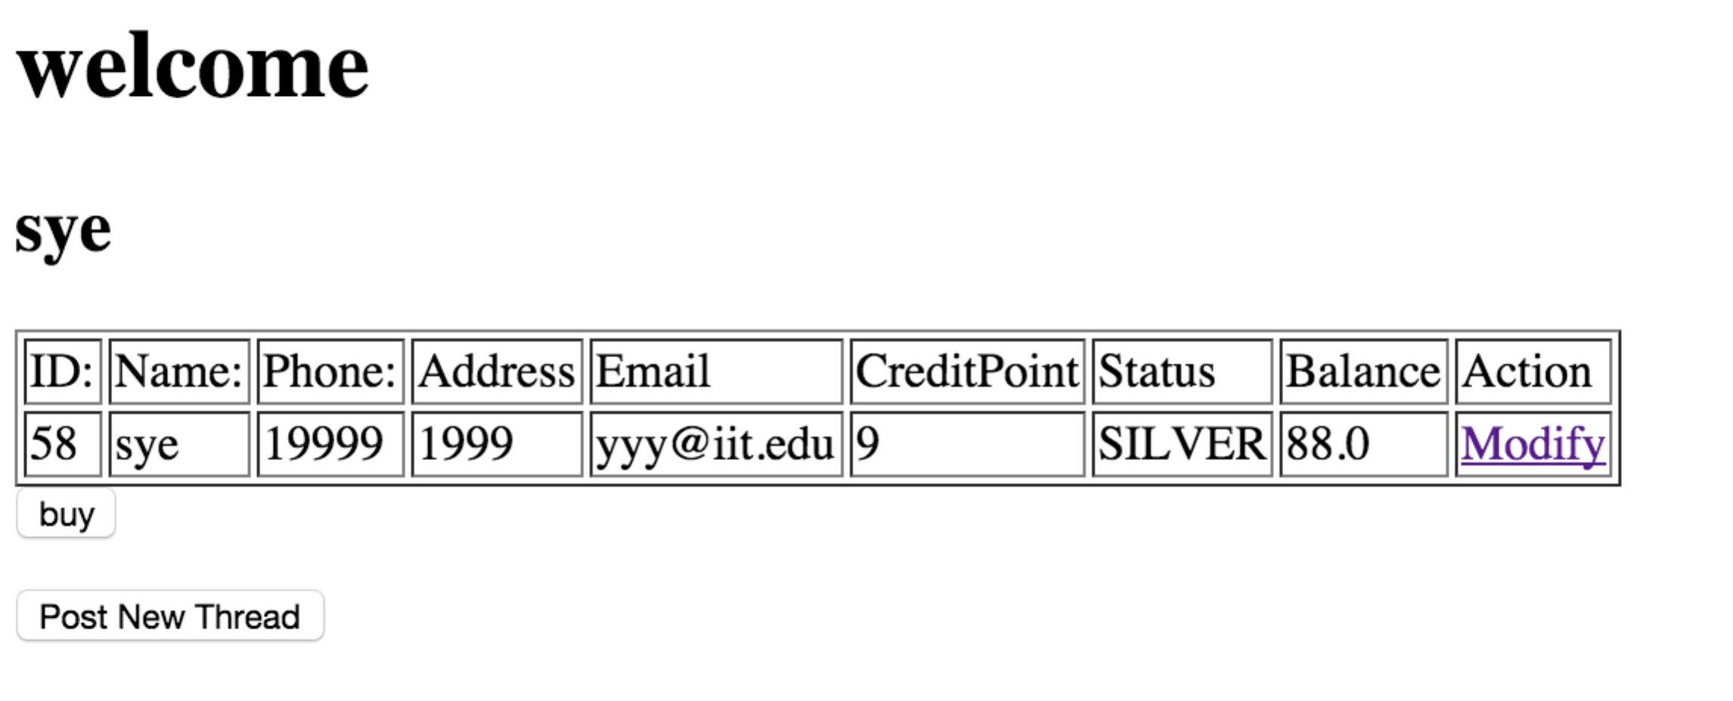

Figure 6 Account Info.

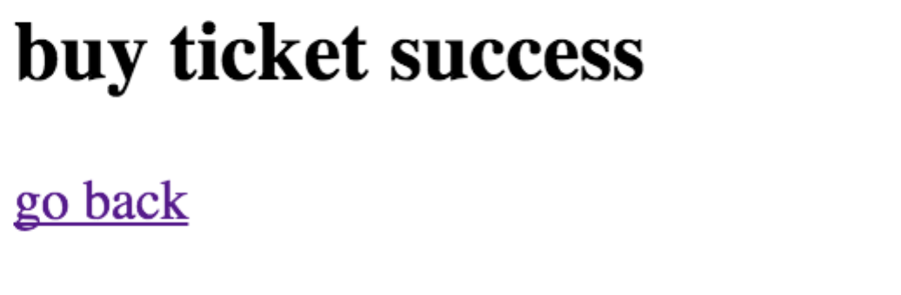

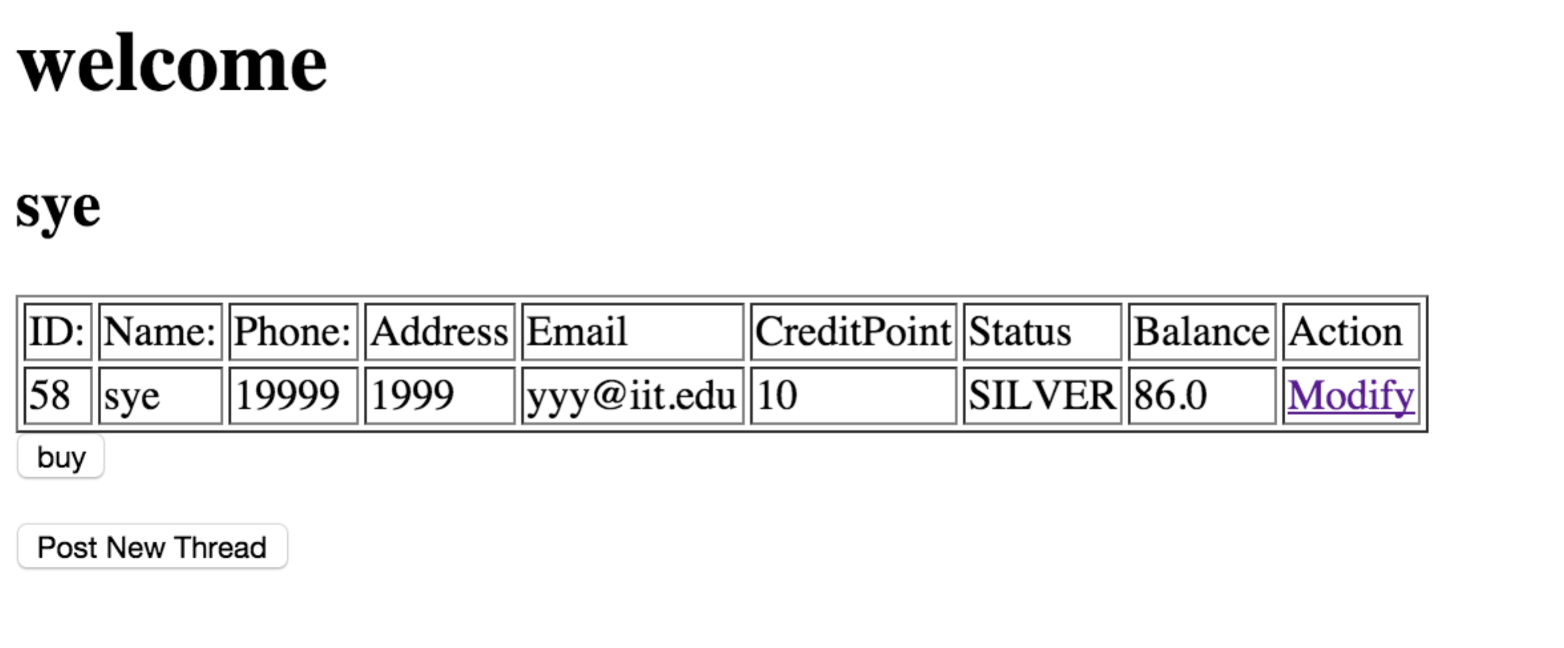



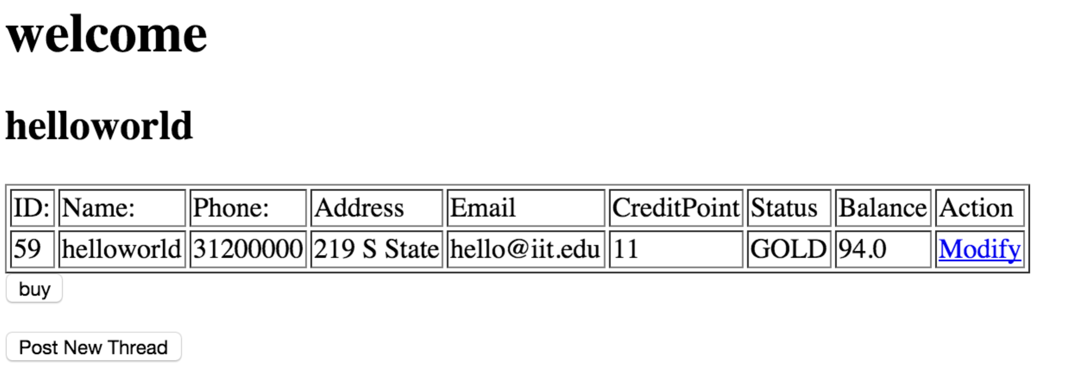

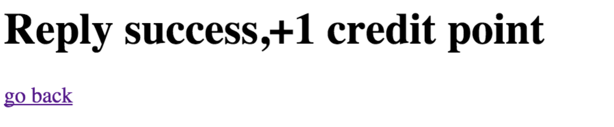

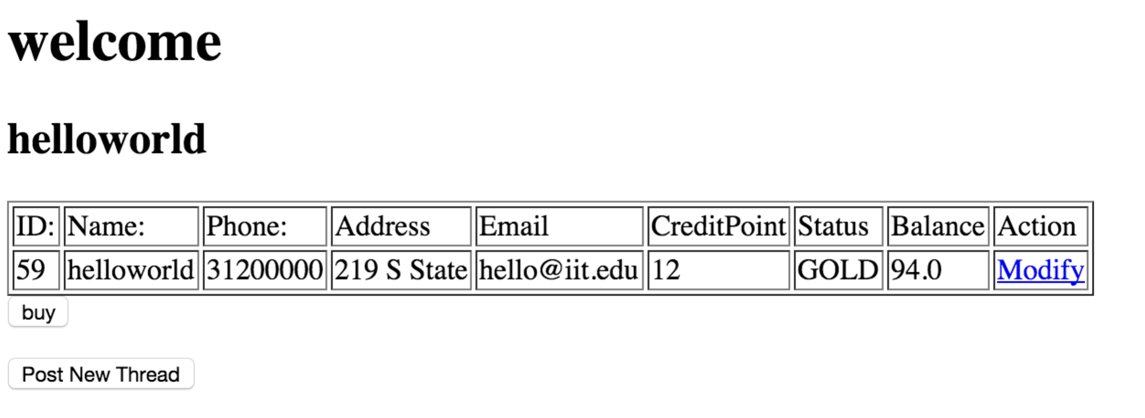

1. Expected outcome: The start creditpoint is 9, once he buys a ticket, he will earn 1 point, if he posts a thread, he will earn 1 point, when he posts a reply, he will earn 1 point.
2. Actual outcome: Same as expect, see pictures above

### Function 3:

1. Requirement: Demonstrate the process of a registered guest logs into his account, adds a comment on an existing thread and starts a new thread.
2. Test Case: once loin to his account, the member will show his account information and there is a button call “Post New Thread”, he can click the button and enter the post thread page, then his will be asked to provide the movie id, his rating of the movie and the comment about the movie, then click submit button, he can also click show message button, and see all the threads, then he can reply to a comment, or see all the replies about that comment.

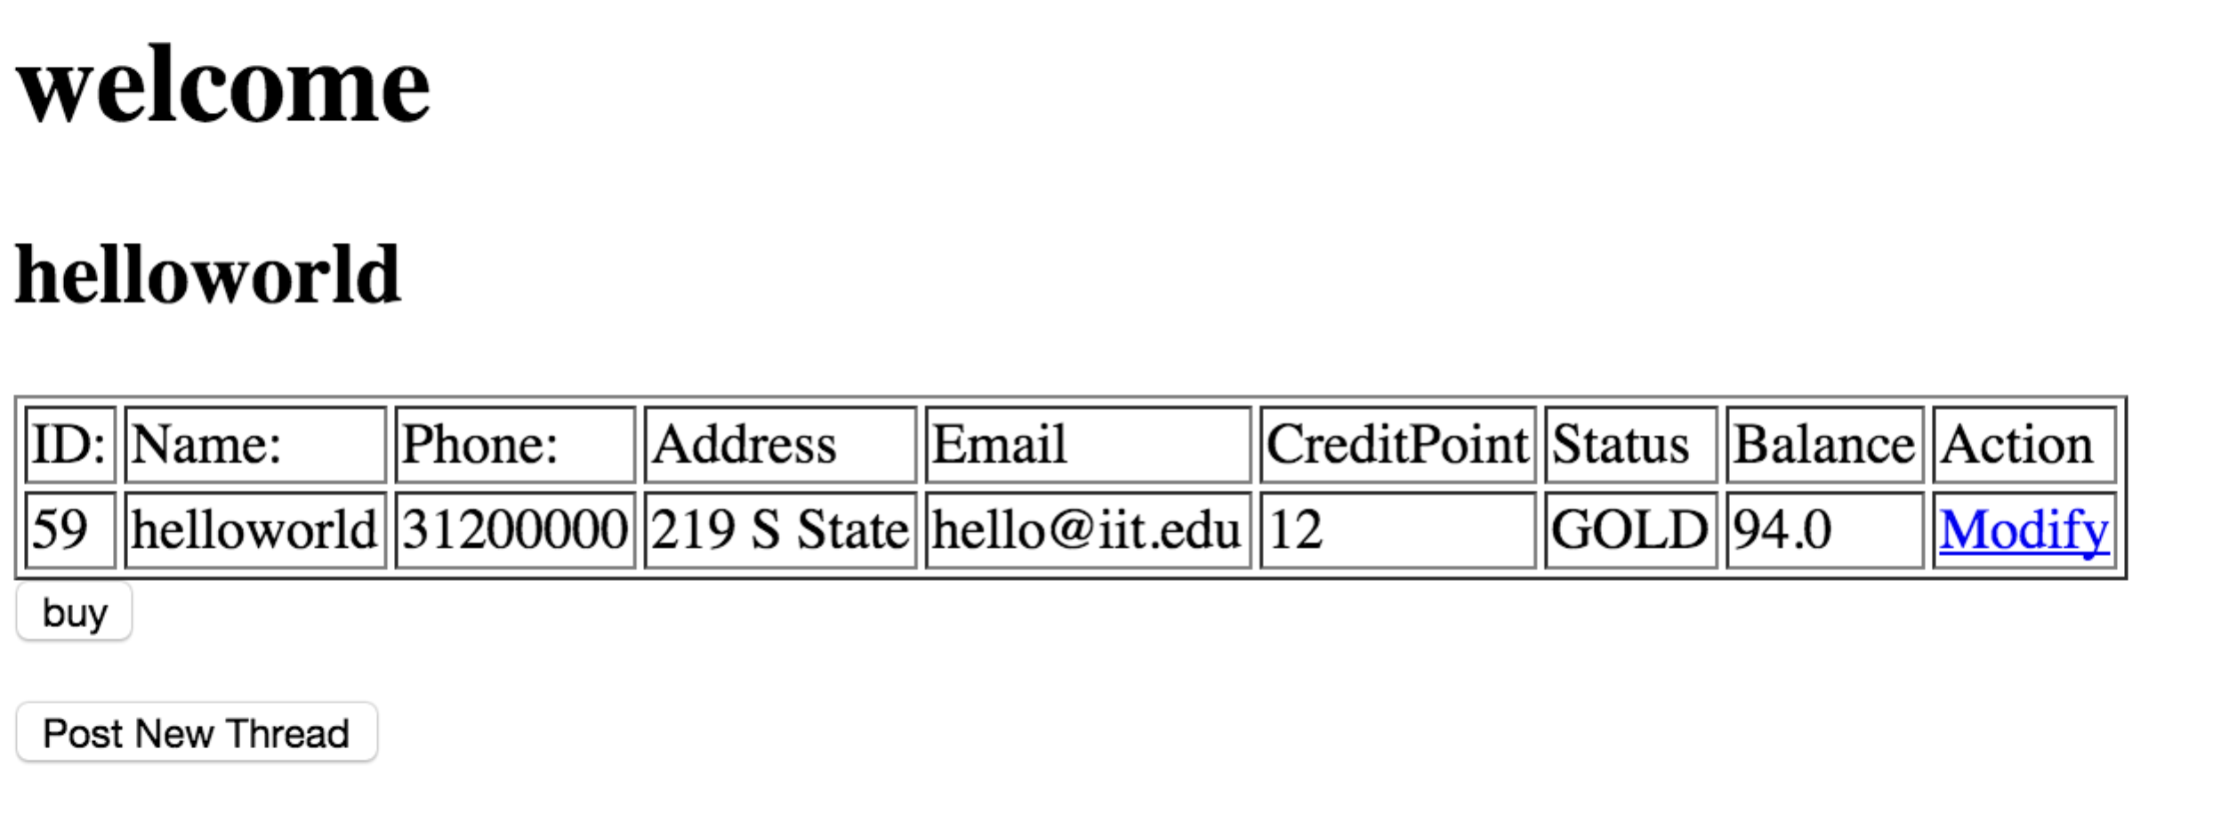

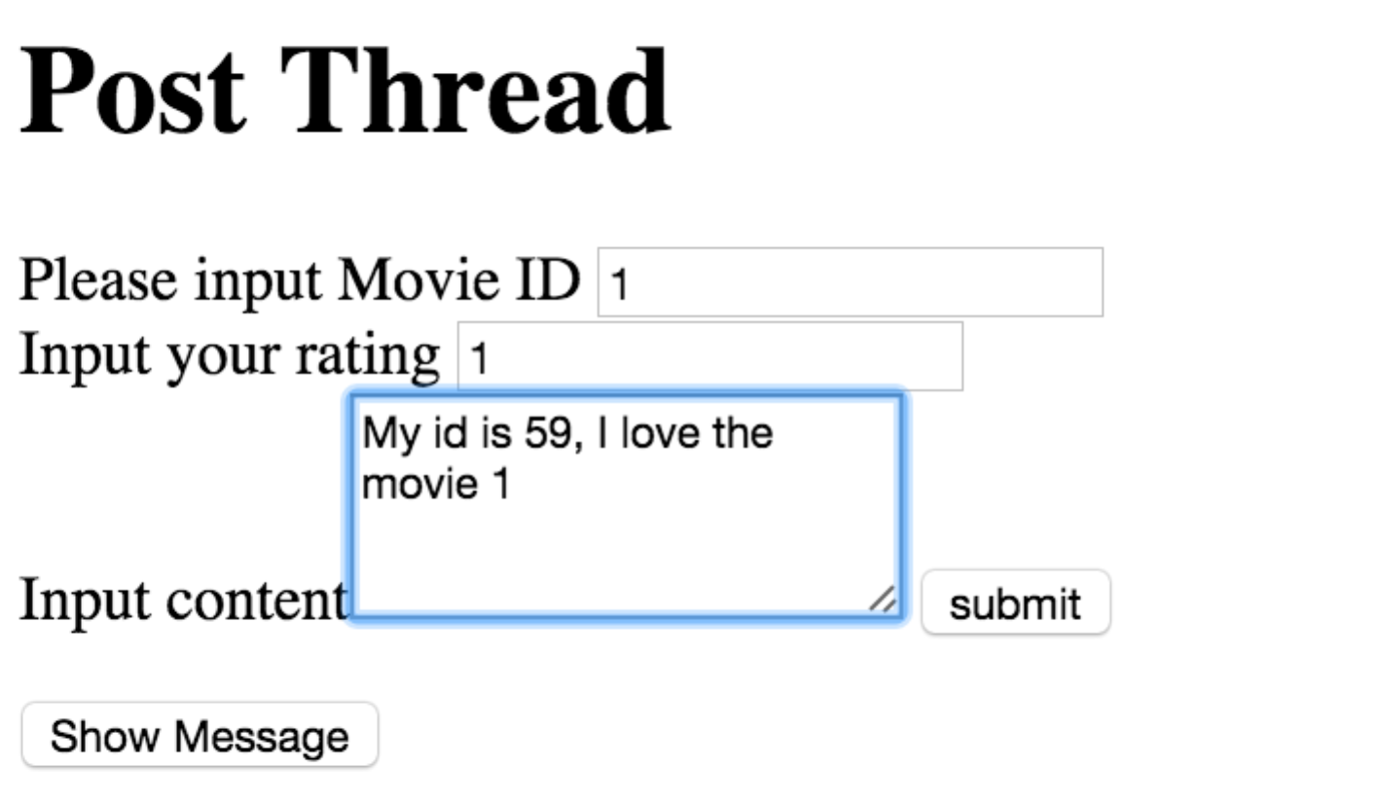



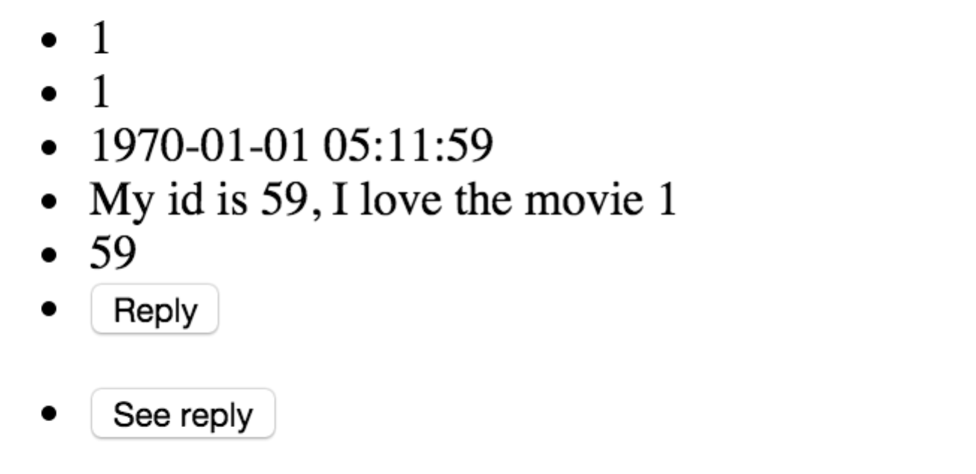

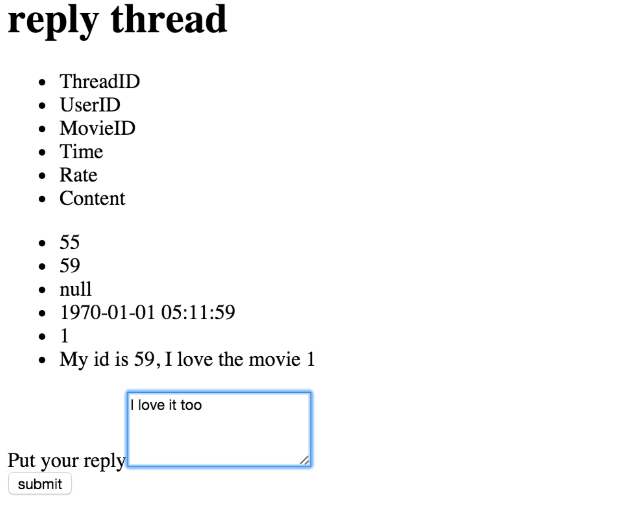

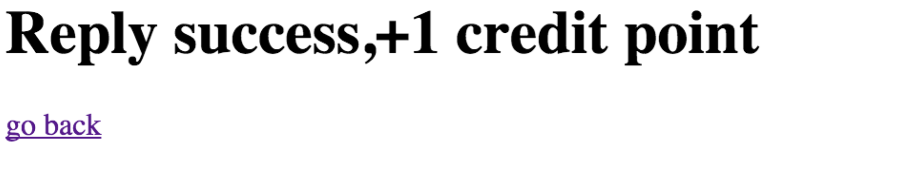

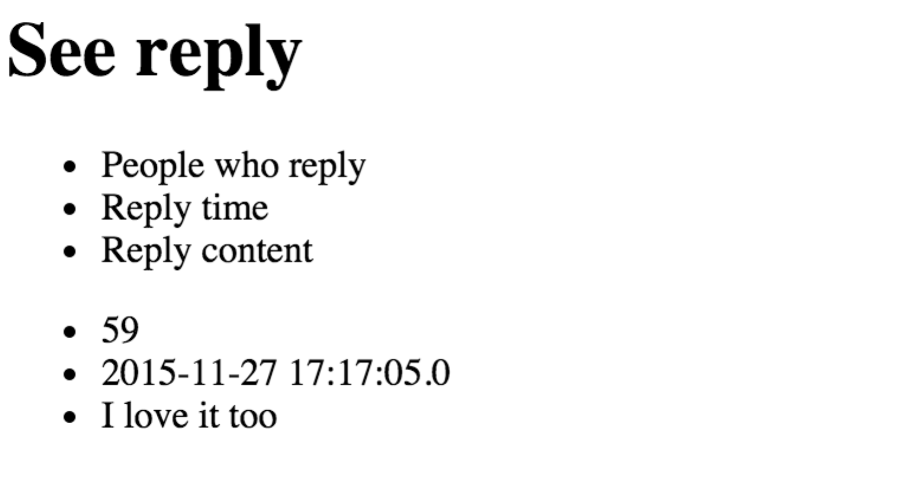

1. Expect outcome:

There will be both the thread that the user post and the reply he post stored in the database.

1. Actual outcome: screen shots are as above

In database:

The thread



the comment

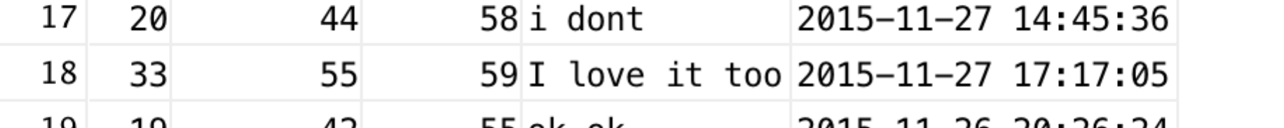

### Function 4:

1. Requirement: Demonstrate the process of the general public buys a ticket without registering.
2. Test Case: At the index page, the guest can click “Guest visit” button, then he is asked to provide his information, (if he doesn’t input bank info, he will receive a page that ask him to put card information; if the money is not enough to buy a ticket, he will also be asked to input money again.) and then select the movie and the theater.

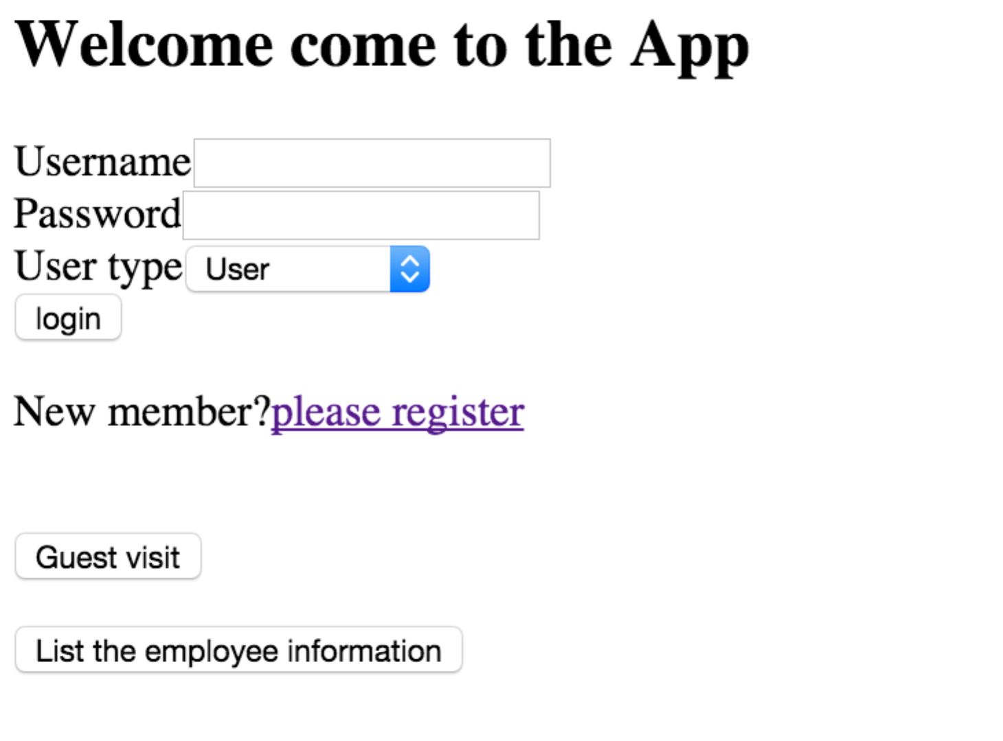

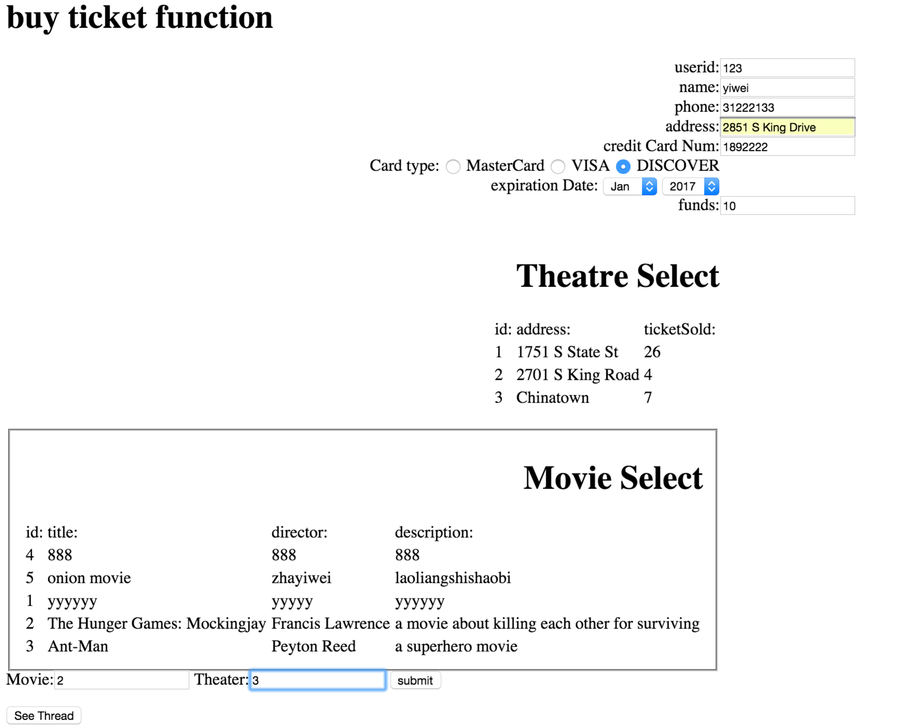



if he doesn’t input the credit card information,

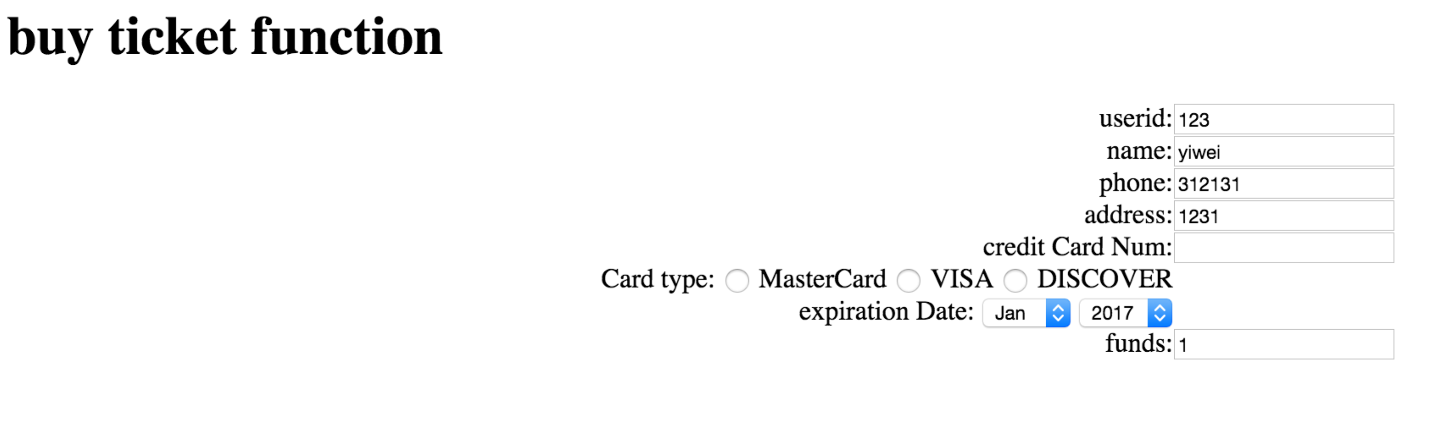

he will be asked to input the card information

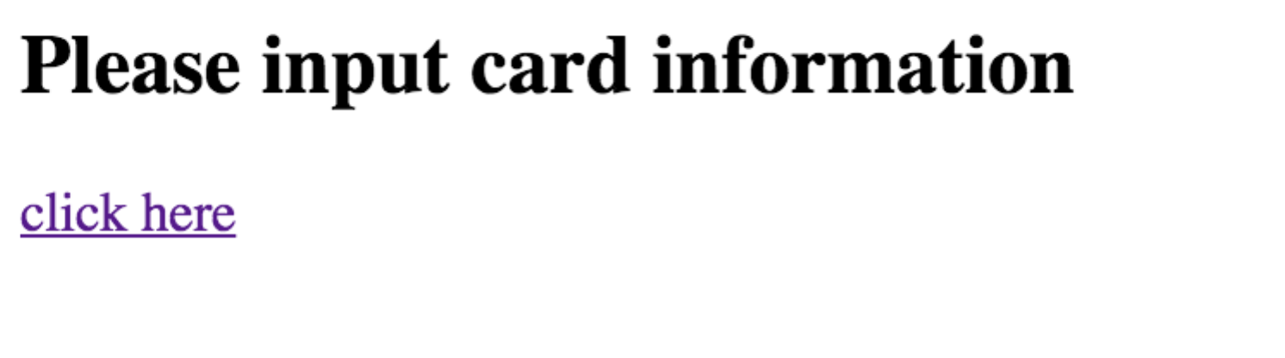

if the money is not enough to buy a ticket

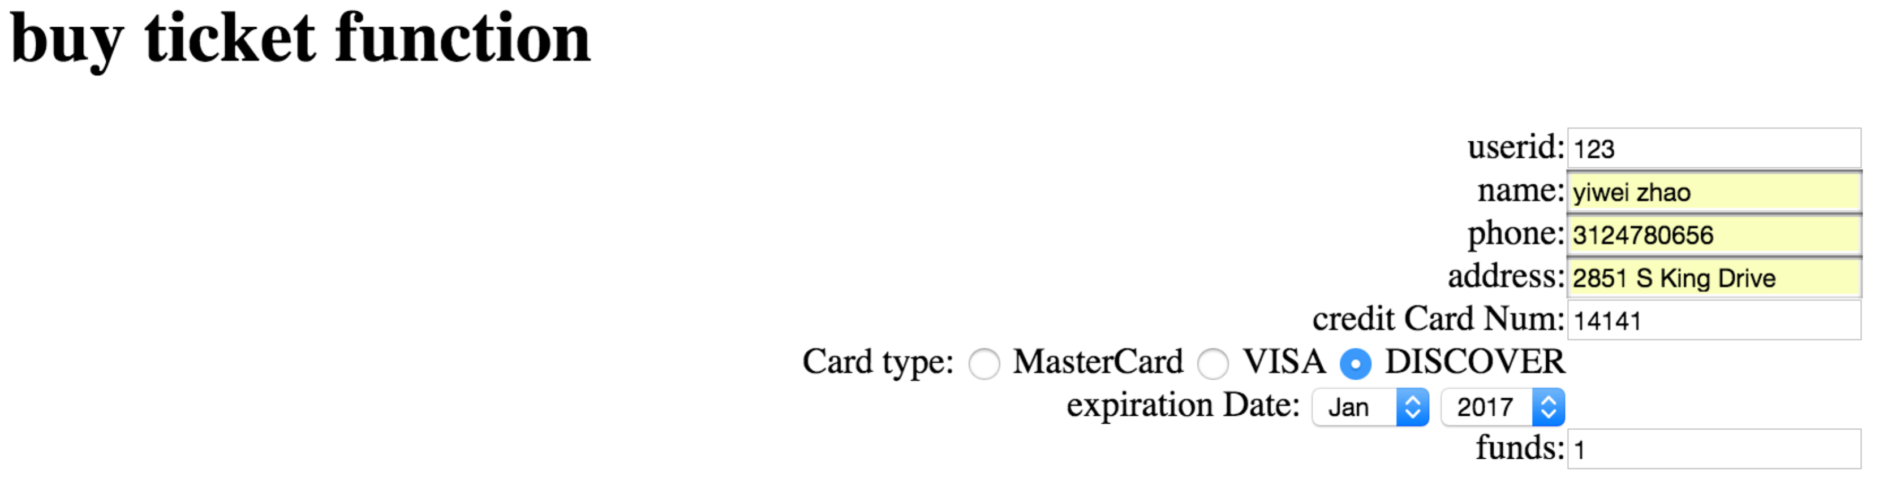

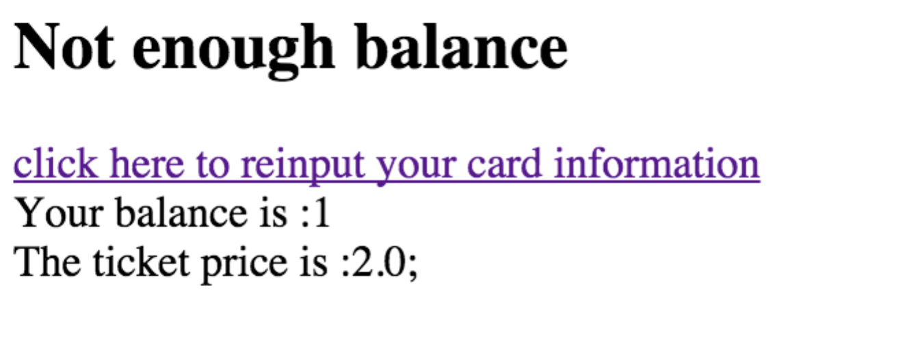

1. Expect outcome:

if he doesn’t input bank info, he will receive a page that ask him to put card information; if the money is not enough to buy a ticket, he will also be asked to input money again

1. Actual outcome:

Same as Expect.

### Function 5:

1. Requirement: Demonstrate the process of the general public visiting the web site and reads a comment on the thread just created, but he cannot enter a comment.
2. Test Case:



At the bottom of the guest visit page, there is a “see thread” function, the guest can click it to see all the threads and replies.

1. Expect outcome: the guest will only see those threads and replies, but not reply on any of them.
2. Actual outcomes:

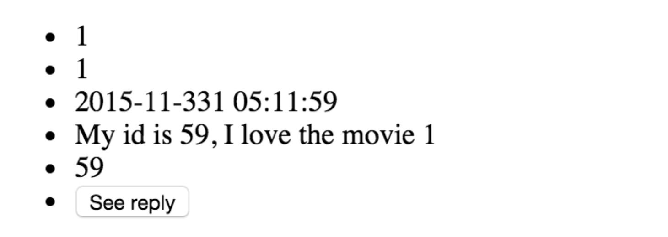

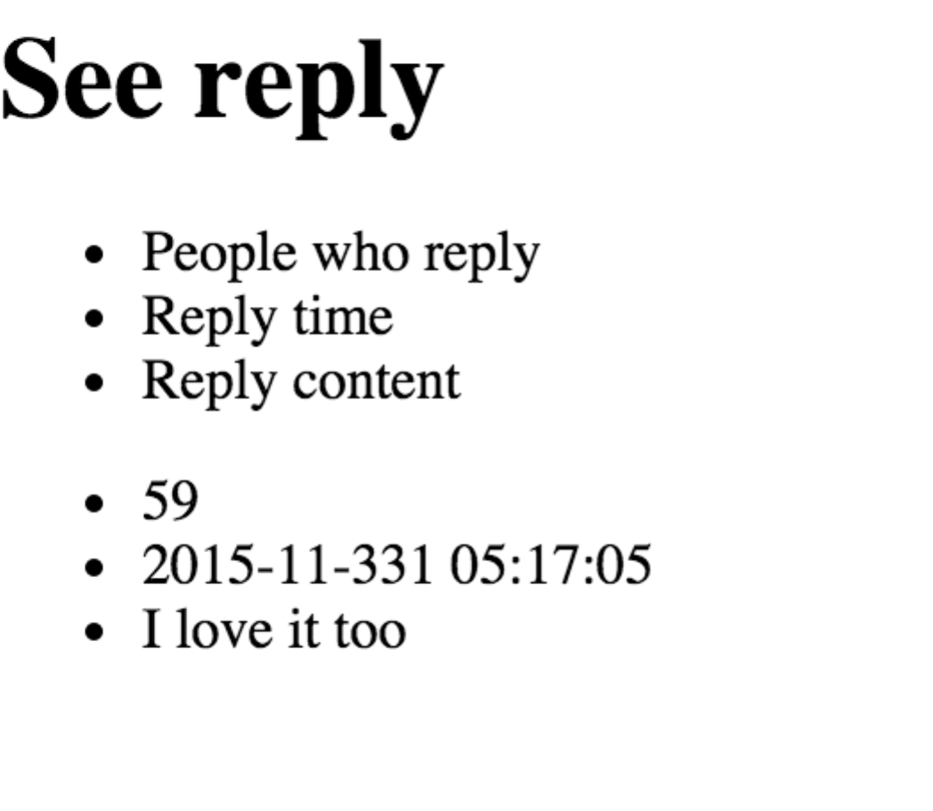

### Function 6:

1. Requirement: Demonstrate the process of the manager making the schedule of an employee on a particular day. Your program will not allow the manager to assign the employee to two different theatres, nor assign the employee the same job at the same time, nor assign the employee a job that he/she cannot do.
2. Test Case: the user should login with username: Francis who is the manager, and enters the password, and select the user type as manager. Then he will see the manager page where the movie information shows and there is a bottom called update worker, after he click it, he will be able to modify the worker information.

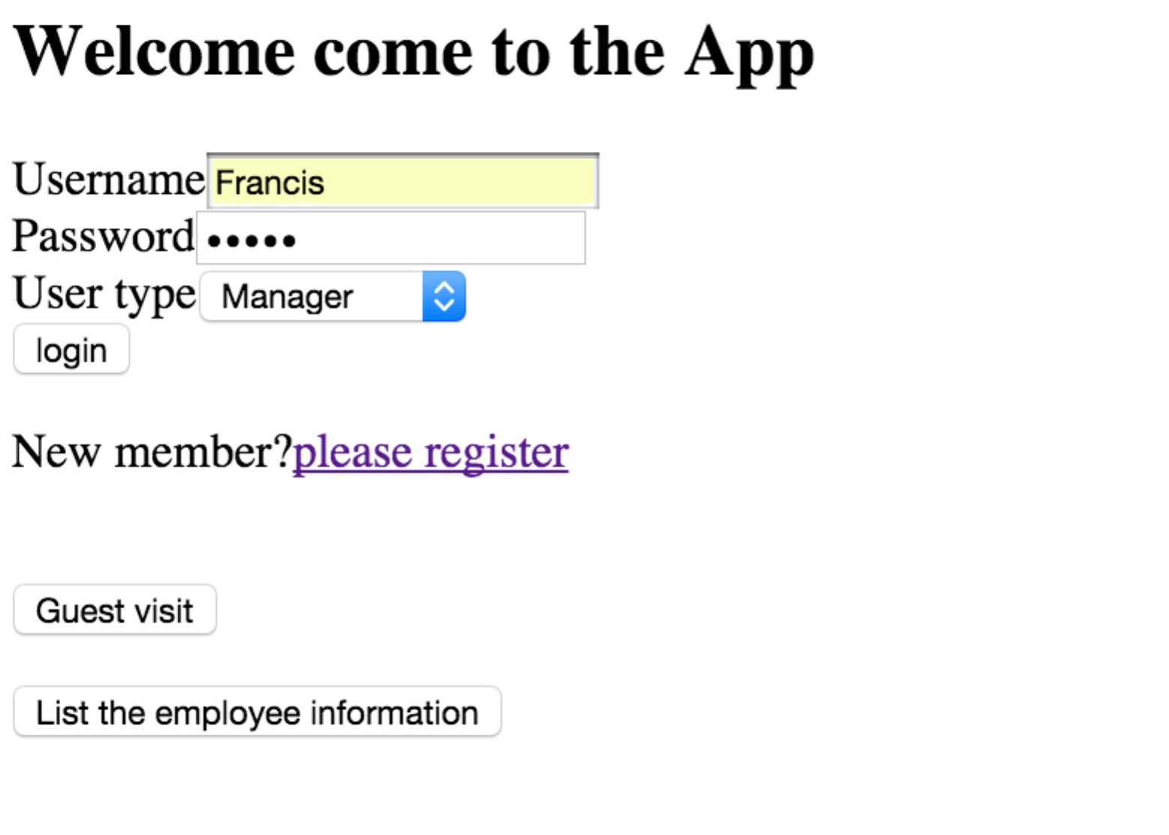

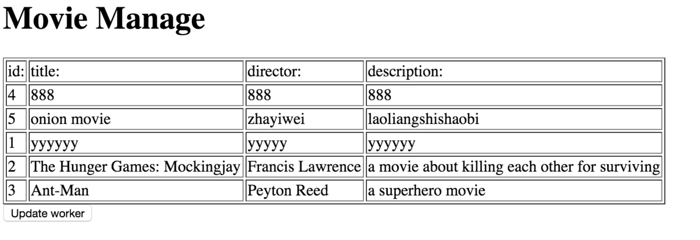

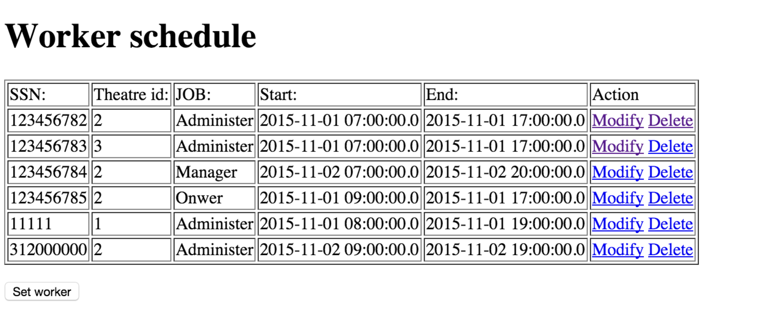

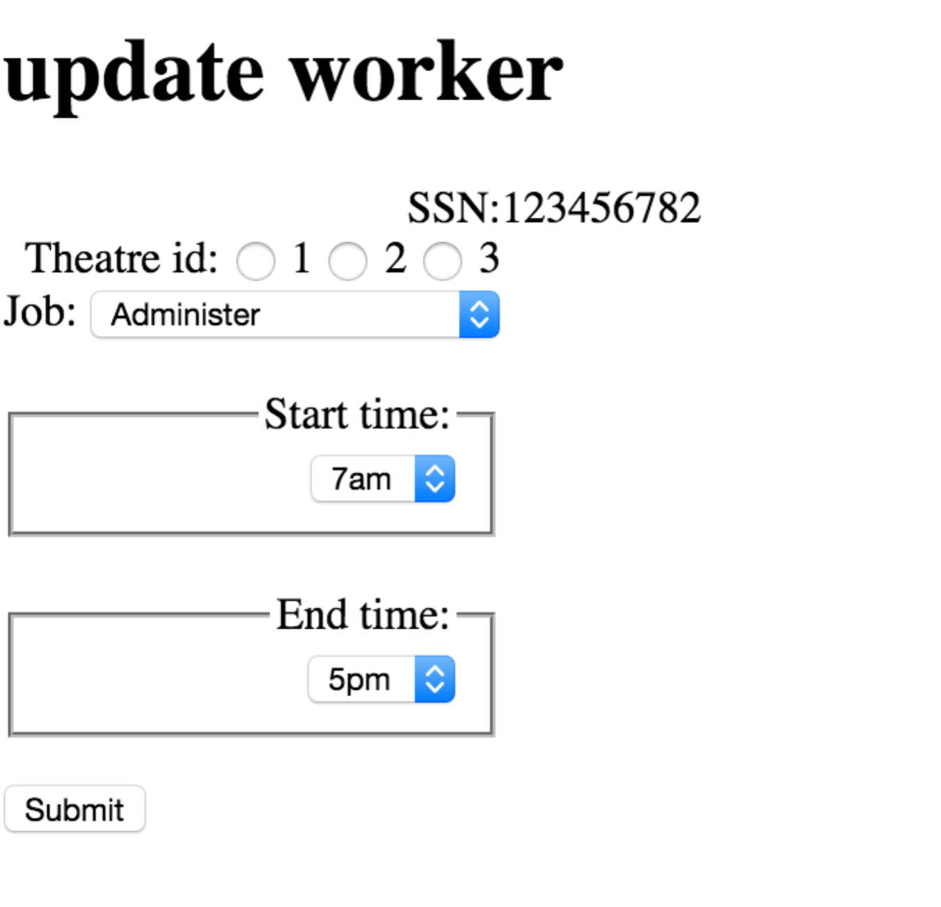

And he can delete a worker too

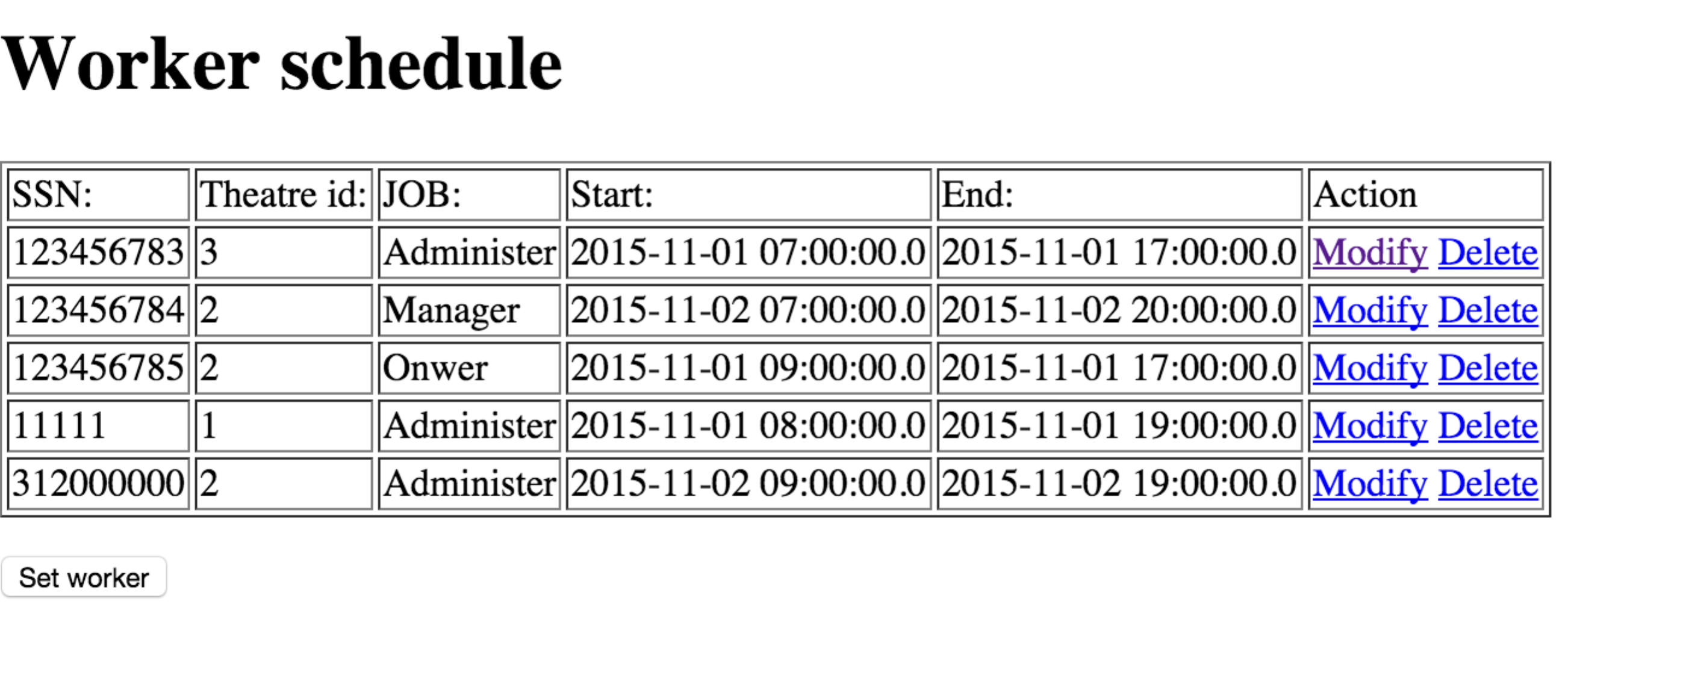

or set a new worker

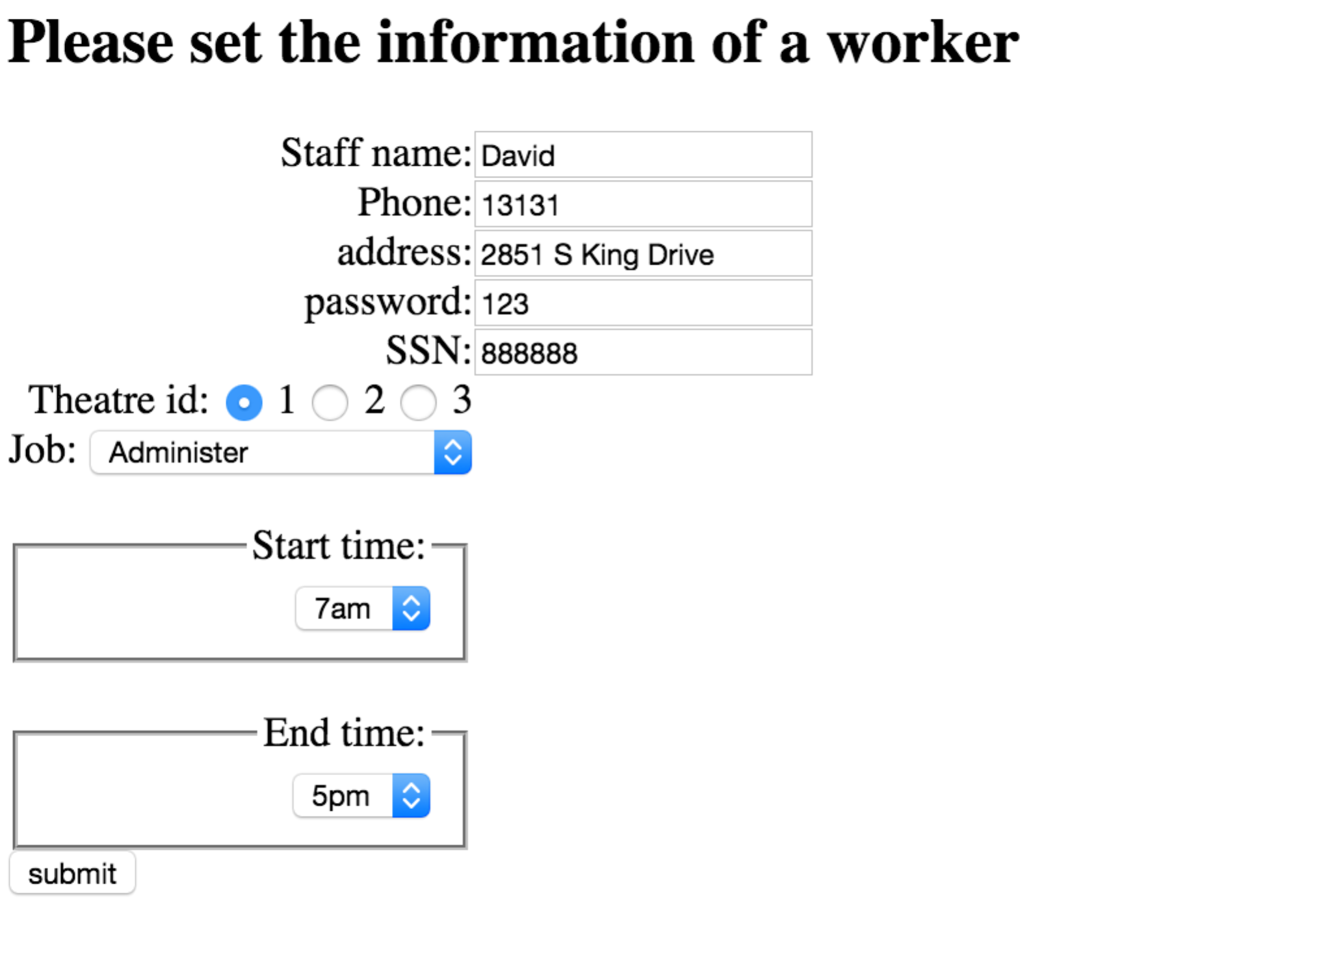

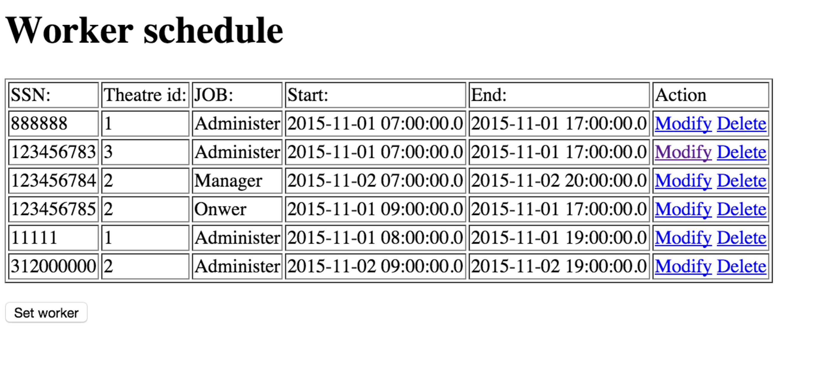

1. Expect outcome: He will be able to set a new worker schedule, delete a worker, and modify an existing worker’s information.
2. Actual outcome: The same as expect.

## Test Data

F15_user:

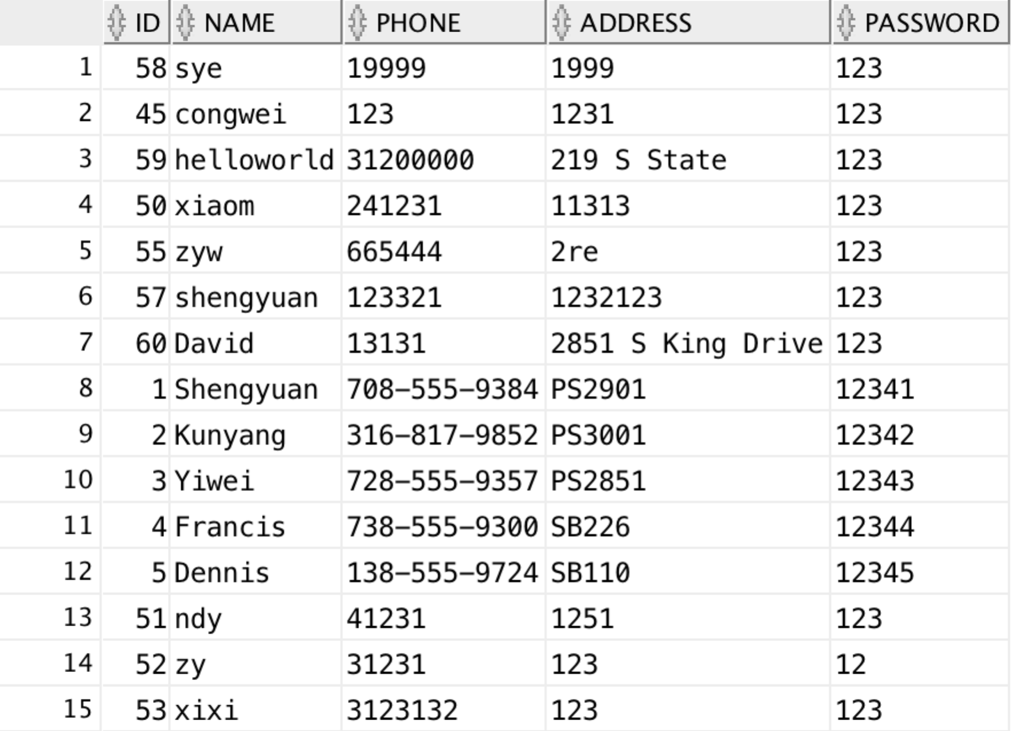

F15_member

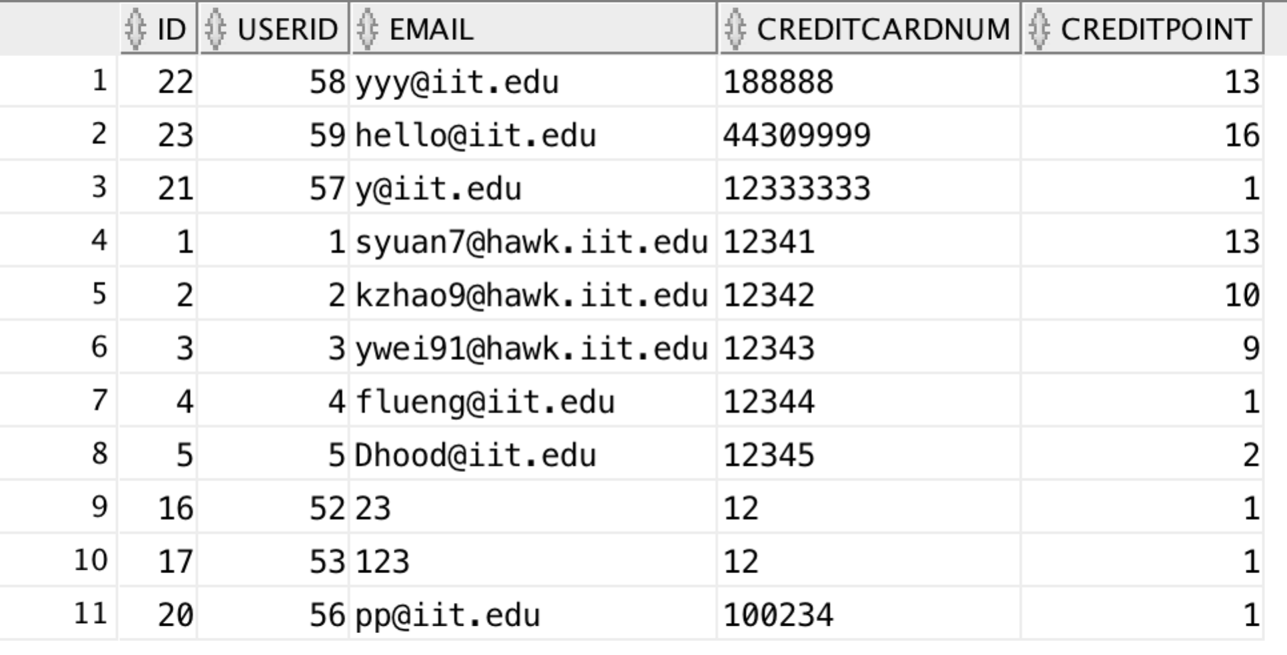

F15_membershipstatus

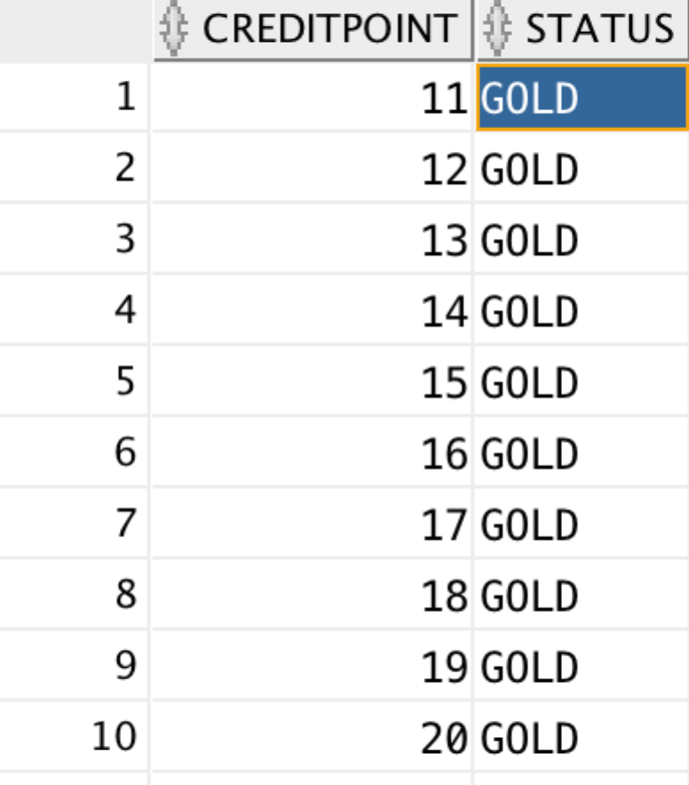

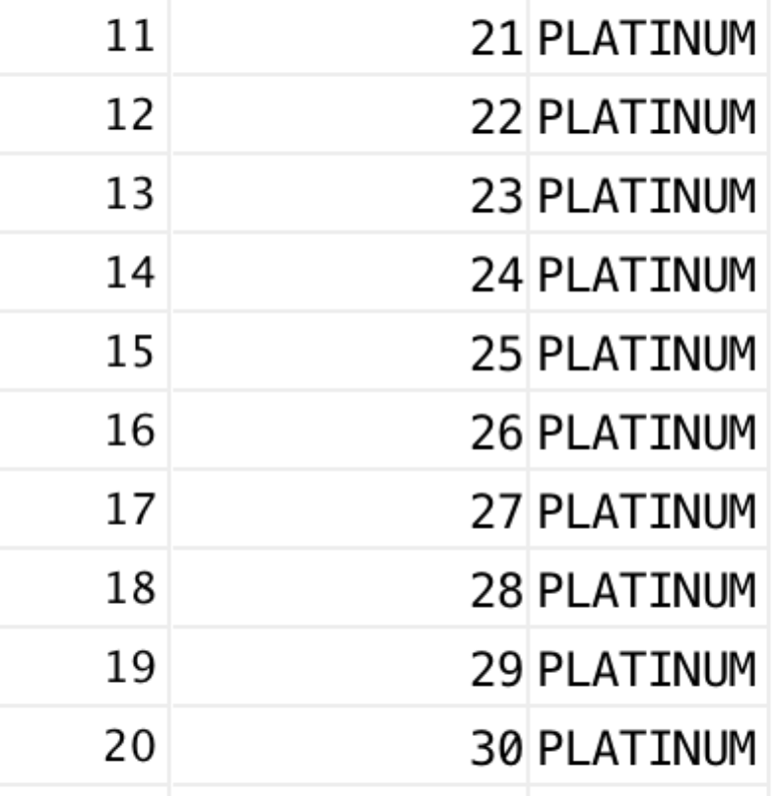

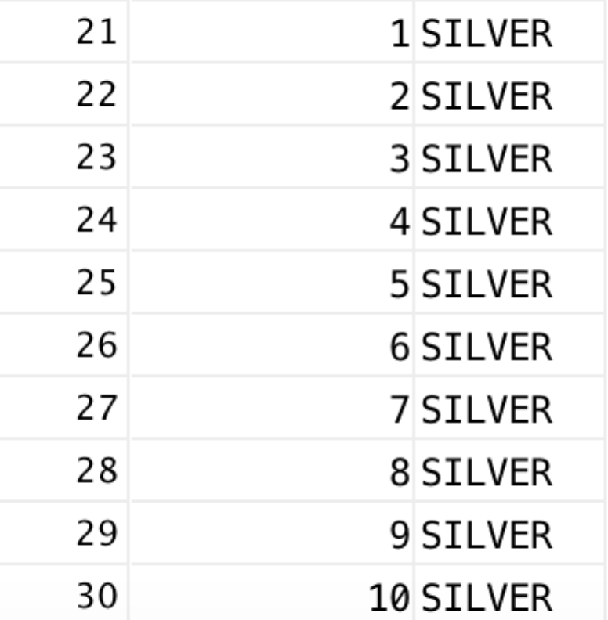

F15_creditcard

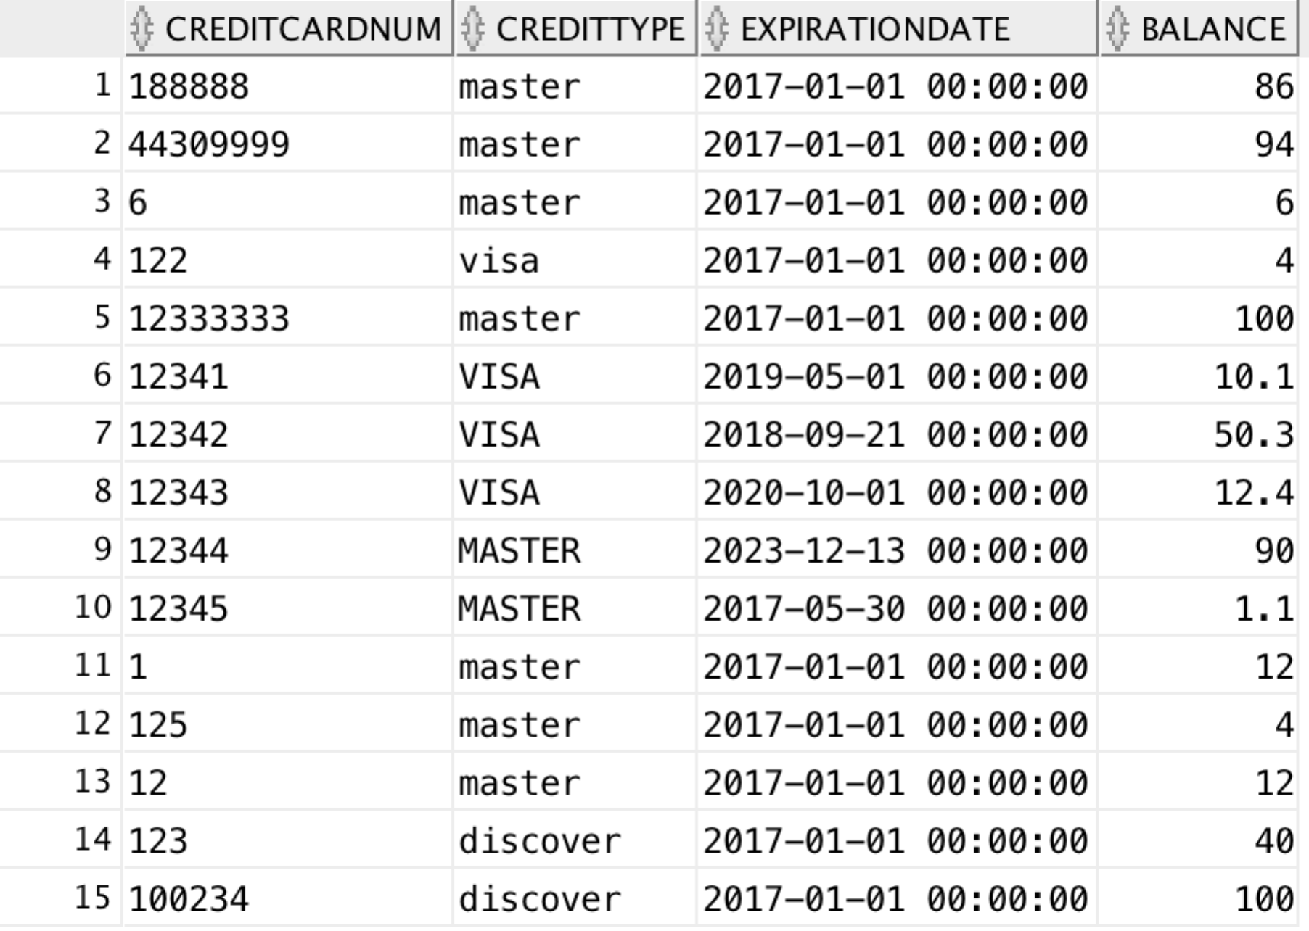

f15_rewards

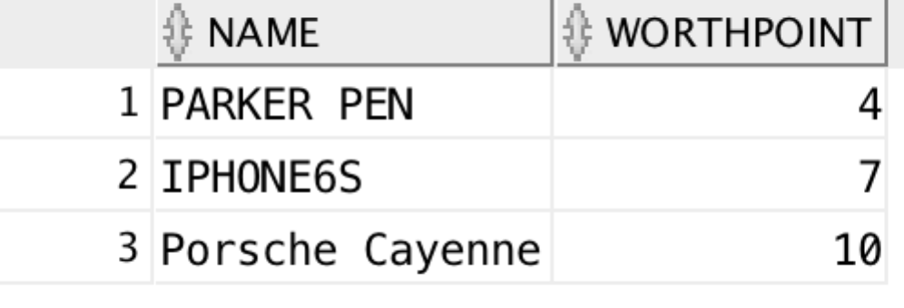

f15_movie

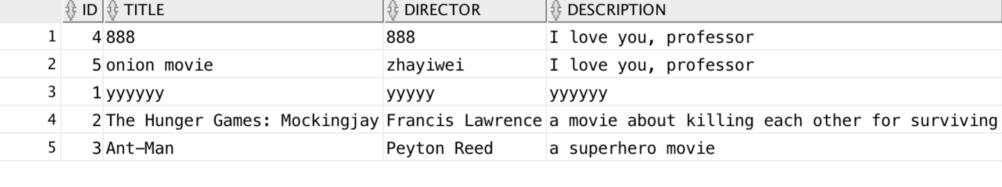

F15_moviestar f15_moviewithstar

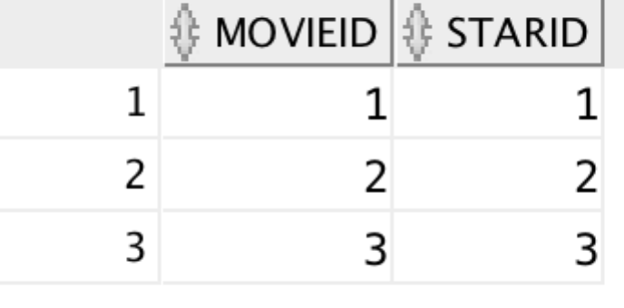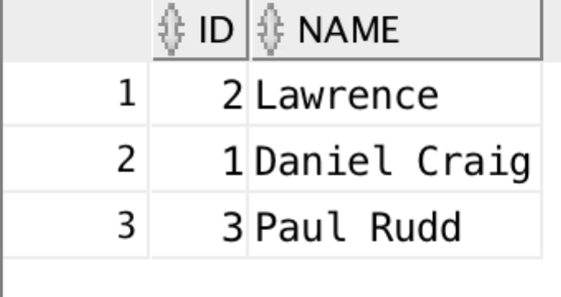

f15_movietype f15_moviewithtype

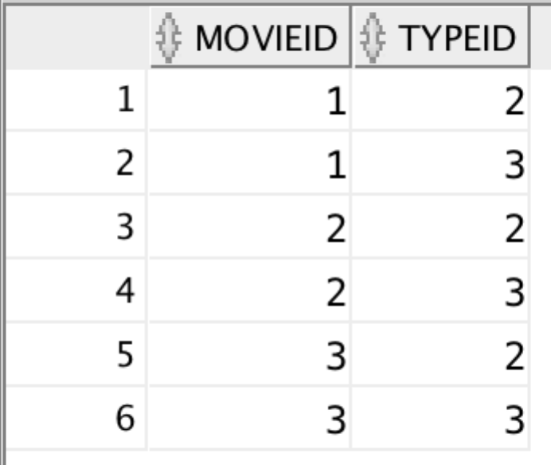

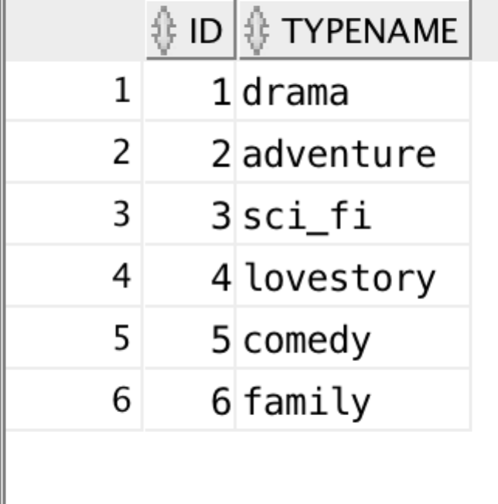

F15_moviereview

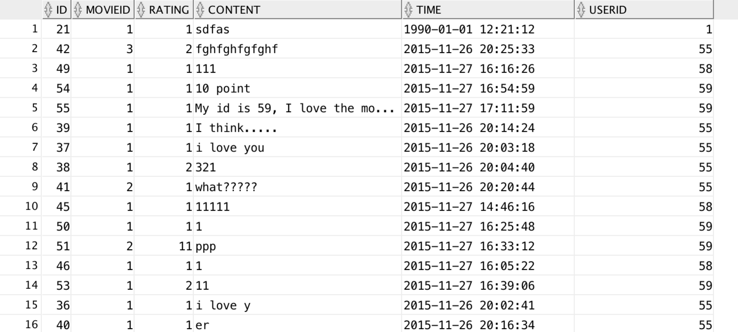

f15_moviecomment

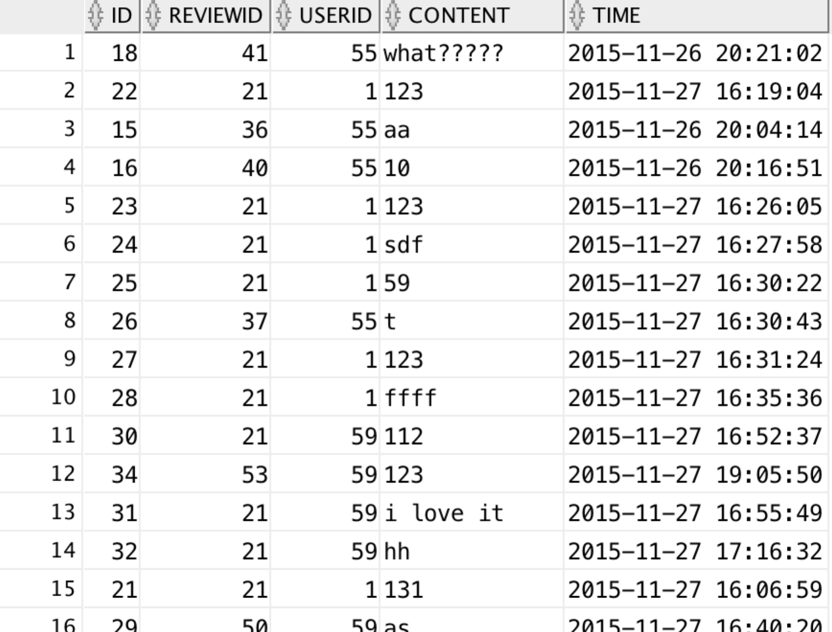

F15_theater

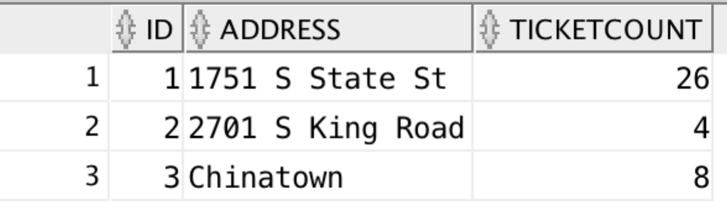

f15_theaterreview

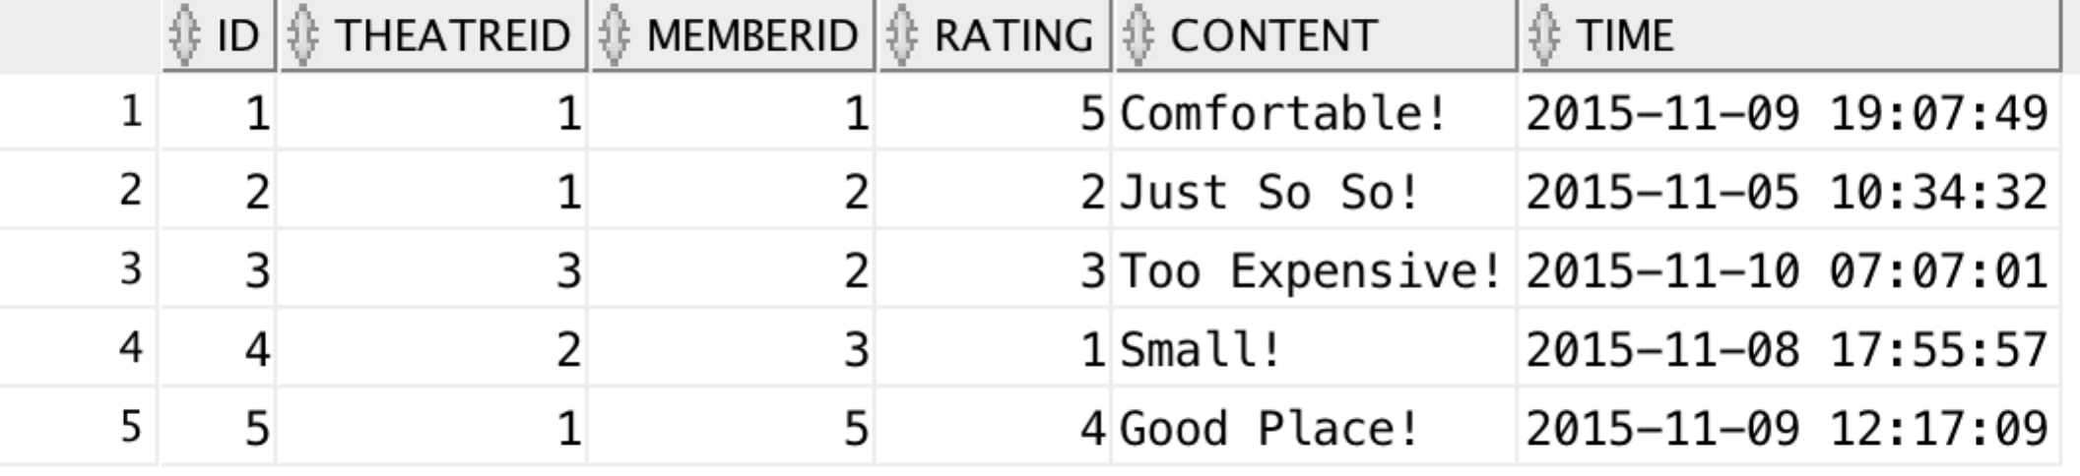

f15_screensroom

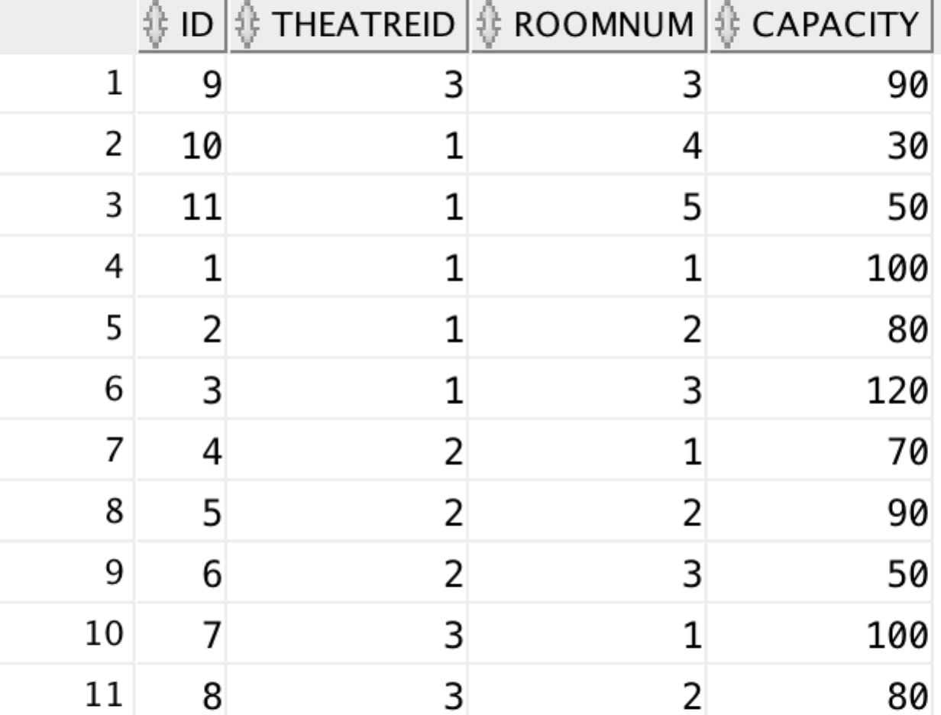

f15_movieschedule

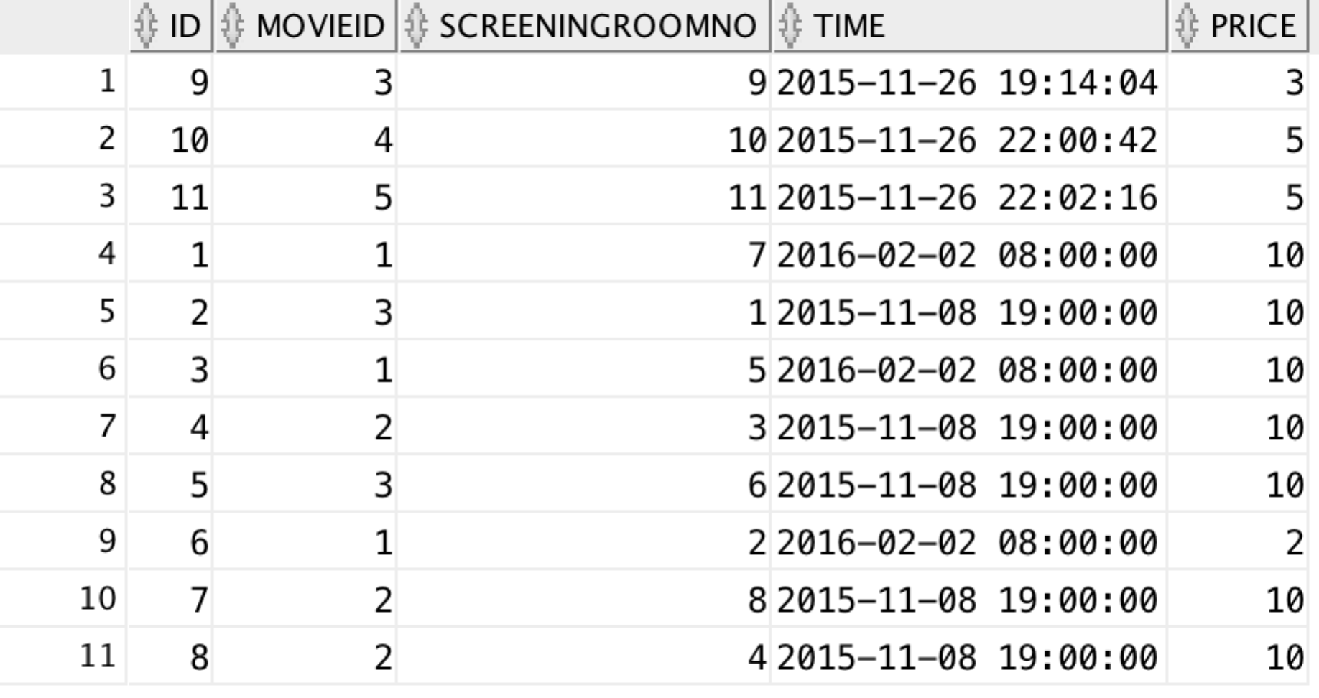

f15_ticket

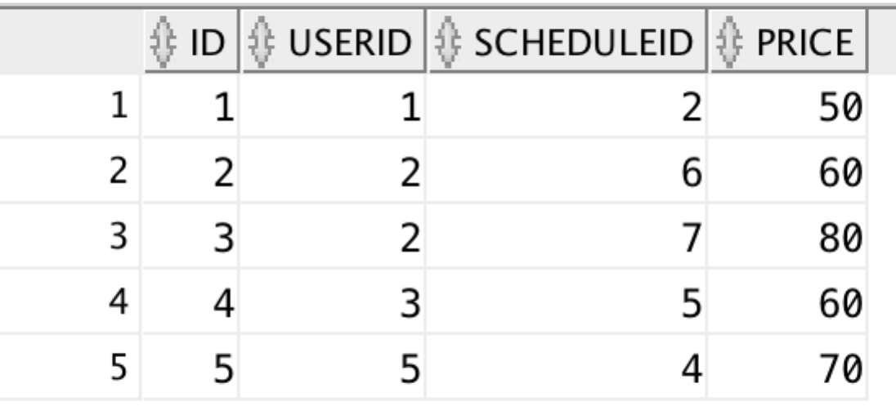

f15_staff

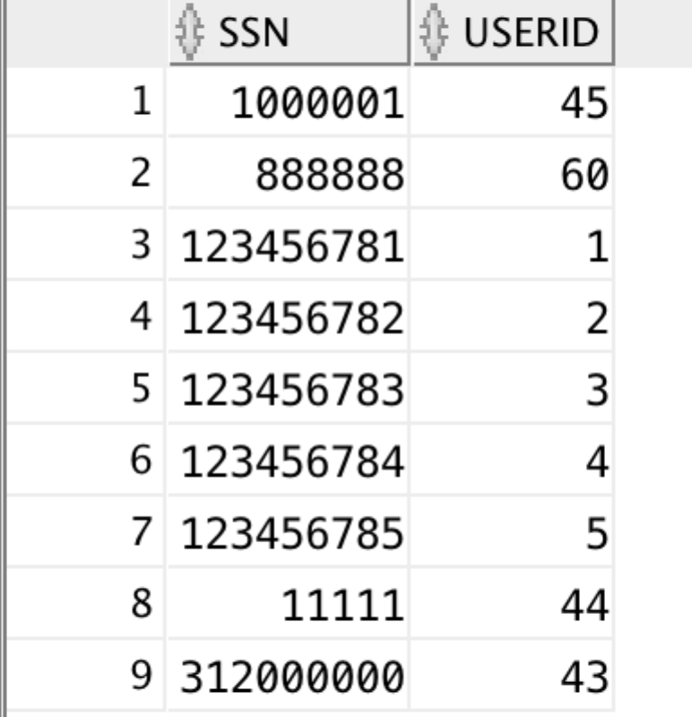

f15_jobtype

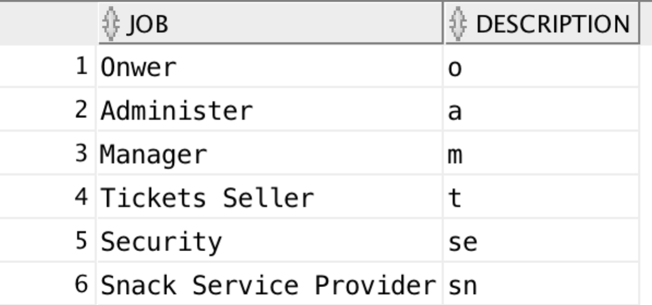

f15_enrollment

